me uTTiciai h'UDiication or alua—An

October 2006

[www.aloa.org](http://www.aloa.org)

Professionals

In This Issue:

CUBE

MASTER

KEYING

PLUS!

Look Ma - No Handle!  
Good Ole’ Motiuation  
H look at NEIL) Products  
RND MORE!

<: % $ % * # <: # * * X % 3-DIGIT 3G3

Breck H. Camp CML PO Box 47070 Atlanta GA 30362-0070

lull.II I I. I 111 I ■ 11 I I 11 I . 1111111111111 ■ 111111111 1,11

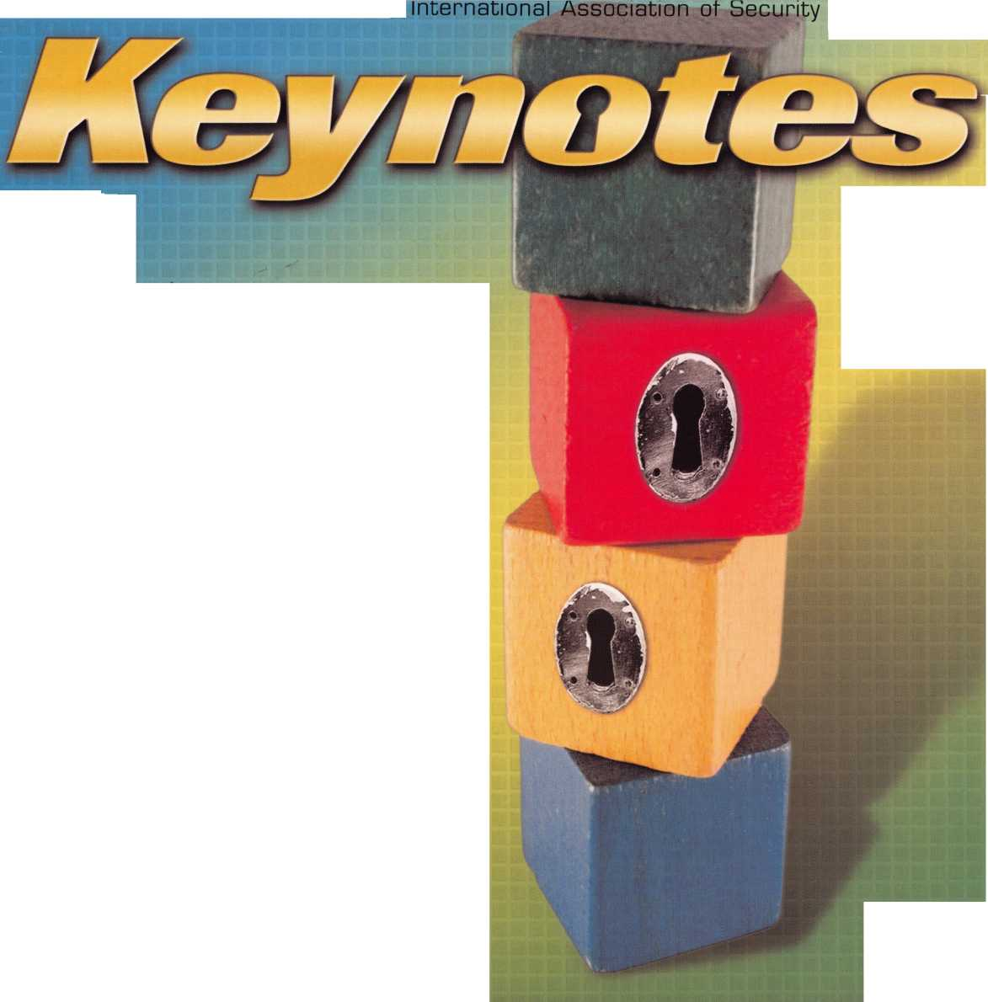

OUR STAND

**IT’S QUITE POSSIBLY YOUR MOST**

TRUSTED SIDEKICK

**Keep it in Good Hands® with Allstate**

As a small business owner, there are few things you rely on more than your vehicle to keep you going Your local Allstate agent can help protect it and your small business with services you need including

quick certificates of insurance, ID cards, assistance with the claims process, and more. All from one of the most widely recognized names in the business.

**Are you in Good Hands®?**

1-800-859-0247

**CALL NOW TO LOCATE YOUR NEARBY ALLSTATE AGENT.**

You're in good hands.

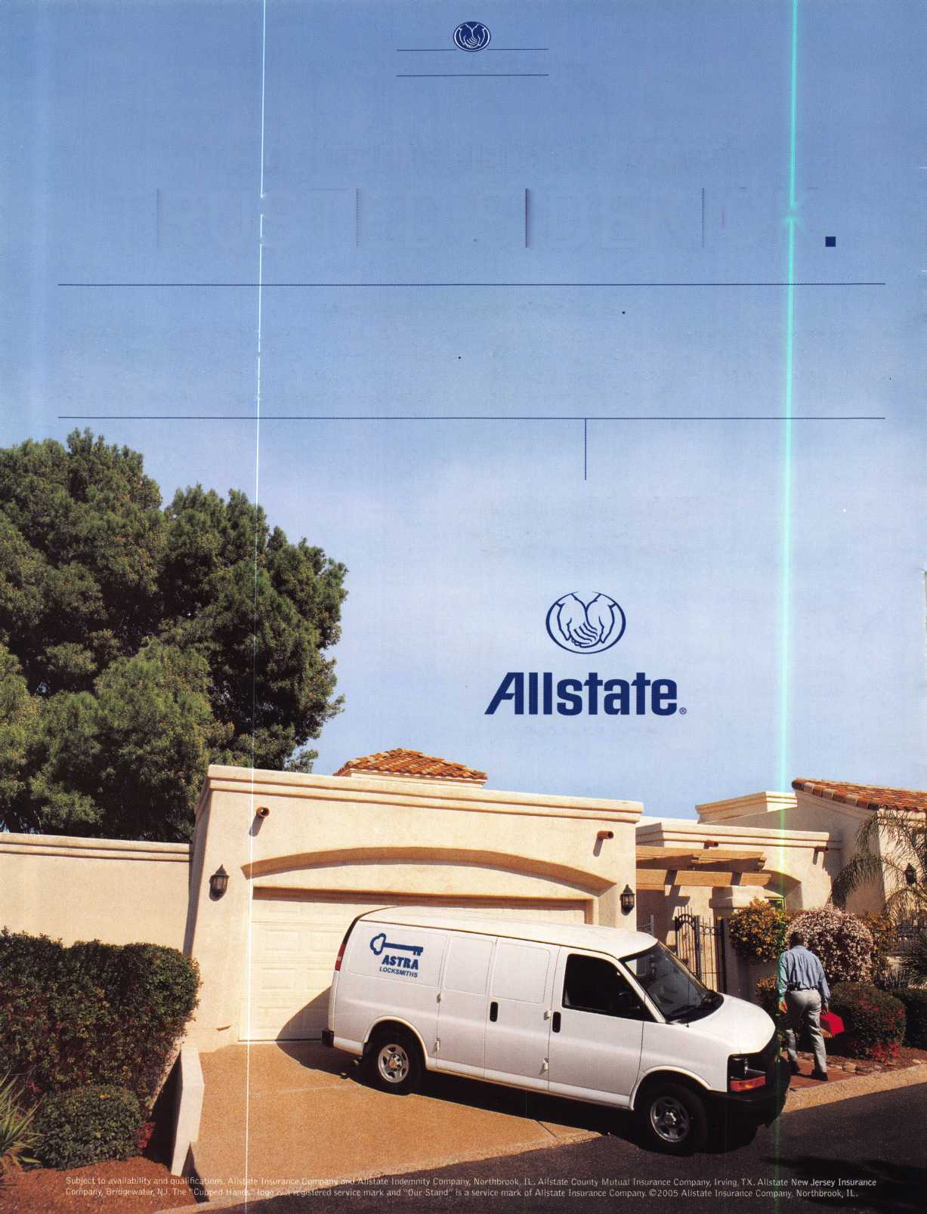

A Name You Know

As a business owner, you know the importance of a good name. Your name is your reputation. Your name stands for all that you offer in products and services. It’s a symbol of who you are. So, we thought you might like to know that Allstate, the name you know for insuring your personal vehicle and your home, also offers a business auto policy to help protect vehi­cles used in your locksmith business.

The following are coverages typically included in our business auto policy that might be important to you as a business owner:

Business Auto Liability coverage

* Higher limits up to $2,000,000 per occur­rence.
* Protects you if you are legally responsible for injuries and damages arising out of the ownership, maintenance, or use of business vehicles.
* Cost is based on several factors, including garage location, type and use of vehicle, and the violation and accident activity of your drivers.
* Additional Insured coverage may be required when you contract with govern­mental agencies or bid on local commercial jobs.
* Generally not available on a personal auto policy.
* Usually is no charge to add an insured to a Commercial Auto policy.

Hired Auto coverage

* Provides liability coverage for those vehicles you rent, hire or borrow for business use.
* The premium for hired auto liability coverage is based on the estimated annual rental cost.
* Tools and Special Equipment
* Provides protection to permanently attached equipment on your vehicle.
* You will need to let your agent know the value of the equipment to include in the cost of the vehicle.

You’re good at your business. Your insurance com­pany should be the same way.

Contact an Allstate agent to discuss your business auto insurance needs. To be referred to an agent, please call 800.859.0247 or email [abisO@allstate.com](mailto:abisO@allstate.com).

Subject to availability and qualifications. Insurance coverage is subject to policy terms.

Allstate Insurance Company

Allstate Indemnity Company Northbrook, IL

Allstate County Mutual Insurance Company Irving, TX

Allstate New Jersey Insurance Company Bridgewater, NJ

allstate.com

© 2005 Allstate Insurance Company, Northbrook, IL

12J12JUU 1 L±)L±)UL) ]

db GDC!) CpdDCD

f^r^r5^

clmm

nmnrt*fAX*iggim

Need information in a hurry?

Use ALOA’s Fax On Demand service

Just call 310-575-5027 and receive:

1. ALOA Index of Documents (1 pg)
2. Reasons to Join ALOA (2 pg)
3. Locksmith Career Summary (3 pgs)
4. Locksmith School List (1 pg)
5. ACE Class Schedule (1 pg)
6. Certification Information (5 pgs)
7. PRP Category List (1 pg)
8. ALOA Membership Application (1 pg)
9. ALOA List of Benefits (1 pg)
10. ASF Scholarship Application (1 pg)
11. ASF Scholarship Information (1 pg)
12. ALOA Video Library Order Form (1 pg)
13. Safe & Vault Technicians Association Membership

Application/Subscription Form (2 pgs)

1. Recertification Information (4 pgs)
2. Legislation Action Network Newsletter (2 pgs)
3. Various State Law Issues (8 pgs)
4. Industry Position Paper (1 pg)
5. ALOA Convention Class Schedule (3 pgs)
6. ALOA Convention Class Descriptions (30 pgs)
7. ALOA Convention Registration Forms (4 pgs)
8. Board of Directors Nomination Form (2 pgs)
9. ALOA Company Membership Application (2 pgs)

310-575-5027

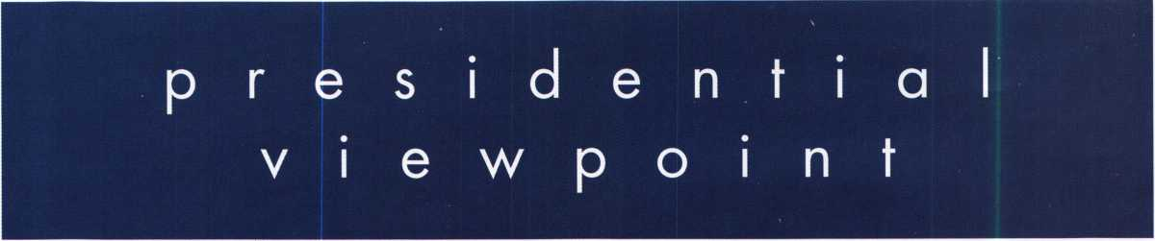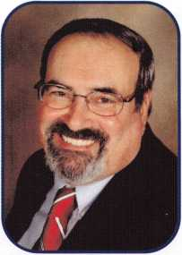

Dear Members,

I, along with ALOA trustee Bill Young, were interviewed by a local affiliate of NBC in late August on the subject of bump keys. We spoke with them and were filmed for close to two hours. This segment, along with other pieces, has been air­ing around the country. In Europe, ALOA's international director, Hans Mejlshede, was on Danish television.

While the use of a bump key has been around for many years, it has not been in use as a sole method of opening locks in favor of many other methods used by locksmiths. Does the method work? Yes, it does. As with any method, it takes some practice. Is a bump key a specially-made tool? Yes it is. "Now wait," you may say. "A key is not a tool." When a key is altered and modified, and does not operate as a normal key, then it is a tool. This is why, when anyone explicit­ly shows how to make and use such a tool on the internet or otherwise, is teaching surreptitious entry to the general pop­ulace. If a person had the best interests of the consumer in mind, the information would be.. .This ordinary looking key can be altered by a potential burglar to enter your home. Contact a security specialist on how this problem can be overcome.

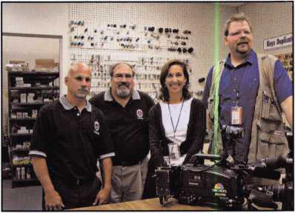

For many years, you, as security specialists, have been  
demonstrating securer locks to your customers. In most cas-  
es, the end result is the same. Most consumers choose the  
lower cost solution. You have also been in enough situations  
to understand that in most cases, the thief entered through a  
door left open or window smashed in. Bump keys had not  
been the problem. Now, I've been informed, locksmiths have  
had customers requesting to purchase bump keys. Needless  
to say, they have been shown the door. For your information,  
ALOA has notified E-bay that because they are selling bump

keys, they are selling burglary tools and should stop.

While we were addressing the bump key issue with the

media, we tried to inform them of another serious threat to the consumer, that is, the scammers that are operating around  
the country. Bill Young supplied the reporter with some paper work from one of his customers who fell victim to the scam.  
We hope this will stimulate the media into exposing these con artists who are giving locksmiths a bad name. If you or one  
of your customers has any information, notify the police; notify the media. Also call, e-mail or write Tim McMullen at ALOA  
with any information dealing with these problems.

Some individuals like to engage in lock picking for sport. No problem, but they should have to register their names with the local law enforcement authorities, since they have in their procession burglary tools. Also, if their events are in areas where licensing and regulation of locksmiths is law, then they should have to adhere to the same security checks.

On another note, this is a busy time for me. At the end of September, the fall board meeting will be held in San Diego, California over the ASIS convention. Then it's off to New Haven, Connecticut for the ILA convention. The next week, there's SERLAC in Orlando, Florida. At the end of the month, I'll be teaching at the GPLA convention in Cherry Hill, New Jersey. The GPLA will be honoring ALOA's Fiftieth Anniversary as their convention theme.

Again I would like to reiterate my message of COMMUNICATION. All facets of our security industry need to be in com­munication at one clearing house. Only in this way can we prevent the many problems that harm the general public. I would suggest that clearing house be ALOA

Take 'er easy! Sincerely,

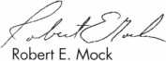

Keynotes

October 2006

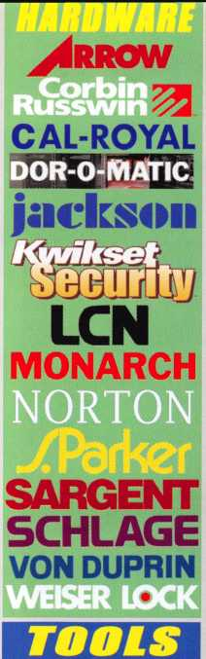

*\*• UHMDI1*

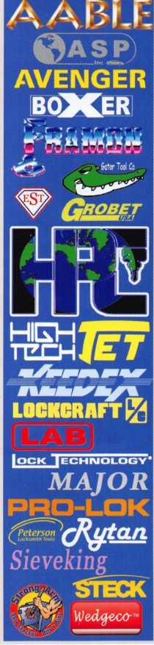

*AUTOMOTIVE ''m*

MIBUUI1 lmhuvtIS

©ASP *HAT A*

***DETERMINATOR ™AJOR ’***

§s. **Dnn-Lnk’**

gSSw

***VISA***

**STRATTEC**

*Wedgec&-*

*ACCESS COMTBOl*

**ES^aiOFUsiiB0/gjr**

**■•KIMlisjil**

oR-o-iwrnc hes

***Why Do***

***Locksmiths***

***Everywhere Buy Supplies at H.L.Fiake?***

*

*\**

*\**

*

*\**

*\**

*\**

*Extremely Competitive  
E/Z Free Freight Minimums*

*Same Day Shipping  
Service with a Smile  
High Fill Rate  
Hard to Find Items*

*E/Z Order Web Site*

***[www.mHAKE.com](http://www.mHAKE.com)***



* ***Order 24 hours a day***
* ***Updated Every Business Day***
* ***Extra Discount for Web Orders***
* ***Personalized Inventory Lists***

*LOG ON TO...*

[WWW.HlFlAKE.com](http://WWW.HlFlAKE.com)

tbfife

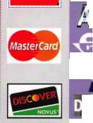

f

e

a

t

u

res

CUBE MASTER KEYING 2006



Cube Master Keying

Read on to find out what Dean Nickel learned about Cube Master Keying.

by Dean Nickel OIL, CPL



Look Ma - No Handle

What do you do when the safe handle falls off? Find out!

by Greg Perry CML, CPS

22

Motivation

Claire reveals the key to supporting the motivation of your employees.

by Claire Cohen



ALOA Dues

ALOA Membership offers SURPRISING benefits!

by Thomas Stern



NEW PRODUCTS

Check out this month's featured NEW products.

**44**

ALOA on Bump Keys

Read this press release to find out what ALOA thinks about the talk surrounding bump keys.

|  |  |  |
| --- | --- | --- |
| r  AD INDEX | |  |
| Allstate | Inside Front Cover | |
| Fax on Demand |  | 1 |
| HL Flake |  | 3 |
| ALOA 2007 |  | 7 |
| Mil-Comm |  | 17 |
| Safetech 2007 |  | 19 |
| Clearstar |  | 21 |
| PBP |  | 21 |
| Doorking |  | 23 |
| Door Jam Armor |  | 25 |
| Ben Jim |  | 27 |
| Coast Safe & Lock |  | 29 |
| Vingcard |  | 31 |
| Turn 10 |  | 31 |
| Jameson Code |  | 35 |
| Adesco |  | 37 |
| A&B |  | 42 |
| Locksmithing UNL |  | 42 |
| E-Key |  | 42 |
| Inkas | Inside Back Cover | |
| CCL  L |  | Back Cover  J |

**Departments**

Presidential Executive 5 Calendar 8 Classified 36 Legislative 40

ViewPoint 2 Applicants 6 Core 9 Associate

Members 38

Visit our NEW website at [www.aloa.org](http://www.aloa.org)

e x e c u

t i v e

Volume 52, Issue 9

Additional contact information for the ALOA Board and most Keynotes authors is  
available through "Locksmith Search" on the ALOA Web site- [www.aloa.org](http://www.aloa.org) or by  
contacting the ALOA office at 3500 Easy Street; Dallas, TX 75247; (800)532-2562;

FAX (214)819-9736; e-mail [aloa@aloa.org](mailto:aloa@aloa.org).

Editor

Betty Southerland [betty@aloa.org](mailto:betty@aloa.org)

Advertising Sales

Kim Hammond voice: 817-645-6778

Fax: 817-645-7599  
e-mail: [adsales@aloa.org](mailto:adsales@aloa.org)

Executive Director

Charles W. Gibson, Jr., CAE [charlie@aloa.org](mailto:charlie@aloa.org)

Associate Executive Director

David Lowell, CML, CMST [david@aloa.org](mailto:david@aloa.org)

Convention & Meetings Manager

Jo Anne Mims [joanne@aloa.org](mailto:joanne@aloa.org)

Operations/Membership Manager

Mary May [mary@aloa.org](mailto:mary@aloa.org)

Director of Creative Services

Betty Southerland [betty@aloa.org](mailto:betty@aloa.org)

Director of IT Operations

Greg K. Jackson [greg@aloa.org](mailto:greg@aloa.org)

Contributors

Jerome Andrews, CML Ray D'Adamo, CML

Paul Chandler, CRL Billy Edwards, CML

Claire Cohen, CML Dan Graffeo, CRL,CMST

Brian Costley, CML, CMST Jim Hancock, CPL

Eric Costley, CRL Jeff Nunberg, CML, CMST

Mission Statement: The Associated Locksmiths of America, Inc. is dedicated to enhancing the professionalism, education and ethics among  
locksmiths and those in related sectors of the physical security industry. With approximately 10,000 members in the United States, Canada and the  
freeworld, ALOA is poised to help members obtain the knowledge, the strength, and the confidence to perform their role in the physical security field  
with pride and dignity. But it is only through active involvement and participation that ALOA can fully achieve its potential—and can help members to  
achieve theirs.

Policies: **Keynotes**® is the official publication of the Associated Locksmiths of America, Inc. (ALOA). **Keynotes**® acts as a moderator without approving,  
disapproving, or guaranteeing the validity or accuracy of any data, claim, or opinion appearing under a byline or obtained or quoted from an acknowl-  
edged source. The opinions expressed by the authors do not necessarily reflect the official views of ALOA. Also, appearance of advertisements and  
new products or service information does not constitute an endorsement of products or services featured by the Association. The Association does not  
accept responsibility for the inaccuracy of any data, claim, or opinion appearing in this publication, due to typographical errors on the part of the  
authors, Association staff or its agents.

Editor's Note: This publication is designed to provide accurate and authoritative information in regard to the subject matter covered. !t is provided  
and disseminated with the understanding that the publisher is not engaged in rendering legal or other professional services. If legal advice and other  
expert assistance is required, the services of a competent professional should be sought.

Authors' Payment: Payment for eligible submissions to Keynotes will be based on the following criteria: topic, time spent and past contributions. Authors who  
regularly submit to **Keynotes**® are generally paid a higher rate. The latter is especially true of authors who write to fit specific editorial needs and submit said copy  
by **Keynotes**® deadlines. As a general guideline: Average payment for a 750 word, business or light' technical article would be $200. Payment for a 1500 word  
article involving significantly higher time and research efforts would be $400.

Payment will not be offered for articles submitted by ALOA employees or members of the ALOA Board of Directors (unless material is of a technical  
nature), nor for articles submitted by a company that promote that company's products or services. ALOA reserves the right not to pay for articles sub-  
mitted by an individual(s) that promote a particular company's products or services.

Disclaimer: The Associated Locksmiths of America, Inc., (ALOA), reserves the right to refuse any article for any reason. Additionally, ALOA reserves  
the right to edit, amend or modify any article submitted for publication in order to preserve technical accuracy, clarity, fairness or grammatical cor-  
rectness. ALOA will make the best efforts to notify the author of any changes. The extent of ALOA's liability for any article or information contained  
therein will be a notice of correction or retraction in the next possible issue.

**Keynotes**® (ISSN 0277 0792) is published monthly except for the combined June/July issue by The Associated Locksmiths of America, Inc.,  
3500 Easy St., Dallas, TX 75247-6416. Telephone: (214) 819-9733; FAX (214) 819-9736; e-mail [aloa@aloa.org](mailto:aloa@aloa.org). Subscription rates for  
members—$ 15.00 per year. Periodical class postage paid at Dallas, Texas. POSTMASTER: Send address changes to: Keynotes, 3500 Easy St., Dallas,  
TX 75247-6416. © Copyright 2003, All rights reserved. No part of the contents may be reproduced or reprinted in any form without prior  
written permission of the publisher.

Comptroller Kathy J. Romo

Membership Coordinator Shelly Jett

Convention & Meetings Assistant Karen Lyons PRP/Education Coordinator Mayra Ocon

Mail Room Coordinator Kevin Wesley

Graphic Designer Margarita Garza

Accounting Coordinator Joyce Nixon

Executive Assistant Sue Langford

Assistant Education Manager Bob Stafford

Legislation Manager Tim McMullen

Receptionist Shelley Melton

Randy Simpson, CML, CPP Tom Seroogy Robert Stafford, CML Charles Stephenson, CPS

Dave Thielen, CML Dennis Watanabe, CML, CMST

Greg Perry, CML,CPS



President

Robert Mock  
(856) 863-0710  
[president@aloa.org](mailto:president@aloa.org)

Secretary

John Soderland, CML, CMST  
(414) 327-5625  
secreta ry@aloa. org

Directors, Northeast

Tom Foxwell  
(410) 206-5772

[nedirecfor@aloa.org](mailto:nedirecfor@aloa.org)

Robert D. DeWeese, CML  
(410) 285-0101  
[nedirector@aloa.org](mailto:nedirector@aloa.org)

Directors, Southeast

Tom Gillingham, Jr., CML, CPS  
(615) 264-0747  
[sedirector@aloa.org](mailto:sedirector@aloa.org)

Ken Kupferman, CML  
(813) 232-7600  
sed irector@a loa. org

Director, North Central

William Smith, RL  
(920) 893-5282  
Guy Spinello, RL  
(815) 394-1000  
[ncdirector@aloa.org](mailto:ncdirector@aloa.org)

Director, South Central

CD Lipscomb, CML, CPS  
(903) 874-3522

[scdirector@aloa.org](mailto:scdirector@aloa.org)

Directors, Southwest

Greg Parks  
(858) 271-1155  
swdirector@aloa. org

Julie McCluney, CRL  
(714) 636-5652  
swdirector@aloa. org

Director, Northwest

Keith E. Whiting, CML, CFL  
(360)601-5656  
[nwdirector@aloa.org](mailto:nwdirector@aloa.org)

Director, European

Hans Mejlshede, CML  
(453) 539-3939  
[eurdirector@afoa.org](mailto:eurdirector@afoa.org)

Director, Associate

Dan Floeck  
(800)231-4105  
asdi rector@aloa. org

Trustees

[trustees@aloa.org](mailto:trustees@aloa.org)

Randy Simpson, CML  
(281) 240-5959

John J. Greenan, CML, CPS  
(773) 486.2030  
William Young, CML, CPS  
(610)647-5042

Past Presidents

2003-20C5 William Young, CML, CPS'"  
2001-2003 Randy Simpson, CML*—"

1999-2001 John Greenan, CML, CPS—-*  
1997-1999 Dallas C. Brooks—  
1995-1997 David Lowell, CML, CMST""  
1993-1995 Breck Camp, CML*—*  
1991-1993 Henry Printz, CML—

1989-1991 Evelyn Wersonick, CML, CPS—

1987-1989 Leonard Passarello, CPL*—  
1985-1987 Joe Jackman, CML

1983-1985 Stanley Haney, CPL

1981-1983 Louis LaGreco, CPL  
1979-1981 John Kerr, RL  
1977-'■ 979 Clifford Cox, CML  
] 974-1977 Charles Hetherington  
1972-1974 Gene Laughridge  
1970-1972 William Dutcher, RL  
1968-1970 Constant Maffey, RL  
1966-1968 Harold Edelsfein, RL  
1964-1966 William Meacham  
1962-1964 Robert Rackiiffe, CPL  
1960-1962 Edwin Toepfer, RL  
1956-1960 Ernest Johannesen



Keynotes • October 2006



**applicants**

for membership

CA

Escondido

Roy W. Stinson RL

Lawndale

Tino Macias

San Diego

Arlester E. McDonald

CO

Denver

Andres Milstein

Sponsor: Skip Bladen CRL Thornton

Richard W. Brunner

Sponsor: David E. Thielen CML

FL

Clearwater

Grant H. Grein CRL

Sponsor: Jim H. Dixon Fort Myers

Ike Walton

Naples

Adam B. Cooper

Pensacola

Don King

Tampa

David K. Clark

Sponsor: Robert E. DeJonge RL

H I

Honolulu

William H. McIntosh CPL

IL

Chicago

Joseph F. Hercik

LA

Lafayette

Paul H. Sewall

New Orleans

Chad M. Braun Ryan M. Braun

MA

Dorchester

Jason Siegel

Sponsor: David M. Troiano

MD

Silver Spring

Geoffrey K. Buckler

Sponsor: Jerome T Peck CPL

MN

Bloomington

Eric J. Osterberg

Sponsor: Neal P. Campion

MO

Centralia

Ross Ethridge

MT

Poison

Todd E. Rasmussen CRL

Sponsor: Martin Peirce CRL

NH

Goffstown

Roger Chase

NM

Albuquerque

James W. Endicott

NV

Henderson

Gerald R. Howell

Las Vegas

Kevin Glaser

Sponsor: Carroll T. Mann

Richard Carrero

Brooklyn

Alex Fainshtein

SD

Sioux Falls

Jeffrey A. Delker

Sponsor: Troy D. Anderson

TN

Nashville

Osman Hekmat

Normandy

David L. Calvin Jr

Sponsor: Tom Gillingham Jr; CML, CPS

TX

Edinburg

Ricardo Tijerina

Sponsor: Michael J. Buchner Sr Round Rock

Jesse E. Nellis

Sponsor: James L. Hancock CPL

WA

Bellevue

James M. Bliss

Sponsor: David Federico

Canada

ON

Bedfordshire

Yoram Dushek

|Great Britain

Dungannon

Jack Tate

Sponsor: Ken Dale Waterlooville

David Pike

Sponsor: Ken Dale

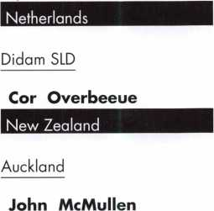

These applicants are scheduled for clearance as members of ALOA. The names are published for member review and comment within 30 days of this Keynotes issue date, respectively, to ensure  
applicants meet standards of ALOA's Code of Ethics. Protests, if any, should be addressed to the Membership Department and must be signed. Active Membership applicants (a) have worked in  
the industry two or more years. Allied Membership (AL) applicants are not locksmiths, but work in a security-related field. Apprentice Membership (AP) applicants have worked in the industry less than two years.

Keynotes • October 2006

Don't miss out!

Order Your Registration Packet TODAY

Start Your Engines!

This year, with a great location and a schedule chock-full of exciting classes and events, we are pulling out all the stops to celebrate the ALOA Convention and Security Expo in Charlotte, North Carolina.

Having built an international reputation among locksmiths as a powerful resource to explore industry innovation and form industry alliances, ALOA 2007 is the ideal place to learn, network or to showcase your security-related business on the show floor.

This year we've thought of everything from an exciting location to a comfort­able hotel and a convention center that is equipped to handle your every need. The exhibit hall promises to be overflowing with the latest technology and new mer­chandise.

july 22-29, 2007 charlotte, north Carolina

aloa convention and security expo

*51st ANNUAL*

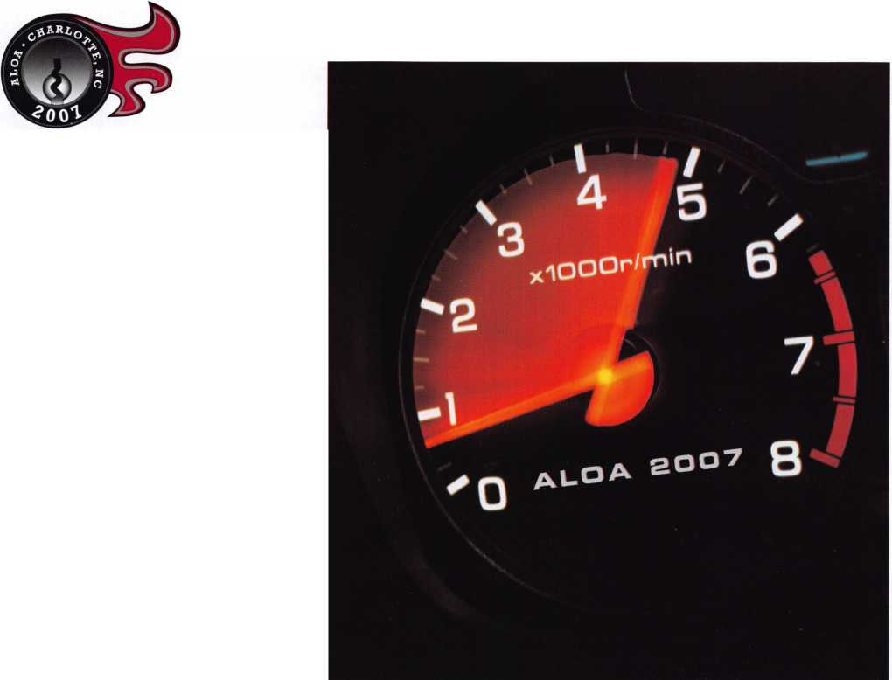

upcoming events

|  |  |  |
| --- | --- | --- |
|  | 10/11 15 SERLAC Convention & Secur | ly Expo |
| 1- | Orlando, FL |  |
| V | Contact: James Barnhardt, R |  |
| 0 | P 813-689-5979 |  |

11/18 OMLA Class - Access Contact: John Ruperd

CCTV, Nurse Call, Etc

'26-3689

**UPCOMING ACE CLASSES**

UPCOMING PRP SITTINGS

10/5/2006 Anaheim, California • ACE C fosses

Clark Security Products Contact: Joan Emrick 619-718-7308

10/10-13/2006 Portland, Oregon • ACE Classes Pacific Locksmiths Association Contact: Bill Botek, CRl 503-644-9881

10/14/2006 Chippewa Falls, Wisconsin • ACE Classes

Indianhead Chapter of ALOA Contact: Kenneth Briggs 715-726-0687

10/16-21/2006 Appleton, Wisconsin • ACE Classes Fax Valley Technical College Contact: Ann Kading 800-735-3882x2482

10/28/2006 Colorado Springs, Colorado * ACE Classes

Central & Southern Colorado Locksmiths Assc. Contact: Phil Poindexter, CRL 719-269-1470

12/4/2006 Dallas, Texas • ACE Classes

ALOA Training Center Contact: [education@aloa.org](mailto:education@aloa.org) 800-532-2562x104

10/12/2006 Thursday 9:00 am • Dallas, TX • ALOA

ALOA Certification 800-532-2562 x203

10/14/2006 Saturday 10:00 am • Portland, OR • Pacific Locksmiths Association

Bill Botek, CRL 503-644-9881

10/21/2006 Saturday 9:00 am • Sturbridge, MA • Yankee Security Convention

Steven McKinney 800-209-8266

10/28/2006 Saturday 8:00 am • Roseville, Ml • LSA

Robert Noble, CMl 810-385-9329

10/29/2006 Sunday 10:00 am • Cherry Hill, NJ • GPLA

Robert Schuetrumpf, CRL 856-486-9280

11 /11/2006 Saturday 8:00 am • Cary, NC • North Carolina Locksmith Assc.

Granger L. Marley 919-859-6060

11/19/2006 Sunday 8:00 am • St. Louis, MO • Bi-State Chapter of ALOA

Kenneth Kim, CRL, CPS 314-351-7252

11 /16/2006 Thursday 9:00 am • Dallas, TX • ALOA

ALOA Certification 800-532-2562 x203

12/9/2006 Saturday 3:00 pm • Dallas, TX • ALOA

ALOA Certification 800-532-2562 x2Q3

Contact the ALOA Education Department for a list of classes and training offered in-house.

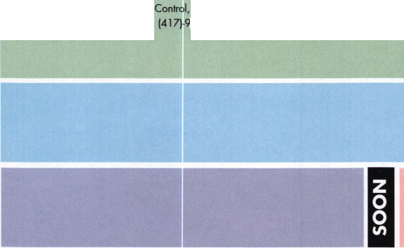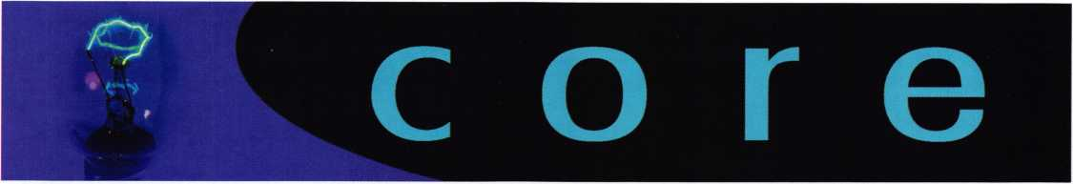

Advertising and Texas Locksmiths

A statement was released from the Texas Private Security Bureau today concerning a ruling made by their legal staff about towing companies advertising under the "Locks and Locksmith" yellow page category. Basically, it says that tow companies and presum­ably anyone without a license. It is a small victory, but it is a victo­ry none-the-less. This has been an issue heard from members for a long time. Jim Hetchler asked for the ruling and it was sent back to him for distribution by Lt. Earle Bowie, Supervisor over investiga­tions for the State of Texas Private Security Bureau. This letter may well be used to set future legal precedents and may be usable to solicit similar rulings in other states where licensing is in force.

NASTF Updates

Summary of OEM Service Website Access Charges

The National Automotive Service Task Force (NASTF) recently announced an updated listing on its website which summarizes the OEM service website access charges. All automakers have service websites which make service information available on-line. This includes service manuals, technical service bulletins, training mate­rials, reprogramming information, and other related information (but not key code information).

The access charges for the OEM service websites vary by manu­facturer. To view the summary of access charges, go to [www.nastf.org](http://www.nastf.org) and click on iSummary of OEM Service Website Access Charges?. Most automakers currently offer subscription rates for information on all their models based on daily, monthly, or yearly access. Some offer other options, such as, on a per-doc- ument basis, single-model basis, etc.

Notable changes in the new listing are:

1. Acura and Honda have significantly reduced their annual sub­scription rates.
2. Audi and Volkswagen have adopted 72-hour, monthly, and annual subscription rates in conjunction with their recently launched updated OEM service websites.
3. Kia's access is now free of charge.

Links to all the OEM service websites are available at [www.nastf.org](http://www.nastf.org). Go to the site and then click on "OEM Service Websites".

A Message from the T-Bird Winner

I was absolutely thrilled to win the T-bird. I couldn't believe my luck and good fortune. Whilst not being a gambler, Las Vegas was incredibly lucky for me.

I made my first trip to Las Vegas for the ALOA show in 1982 and have been to every one in that city since. In total, I have been to 14 shows over the years but, for obvious reasons, nothing will ever beat this one. My father has been an ALOA member since the 1960s and if either one of us couldn't attend your convention, then we always ensure that an LSC representative attends.

I would like to thank the Directors of ALOA for this wonderful prize and opportunity. I would also like to thank the sponsors (FKI Security Group, IR Security & Safety, and CompX Security Products). The T-bird promotion was a great idea. It certainly worked very well.

Sincerely,

Mark Johnson

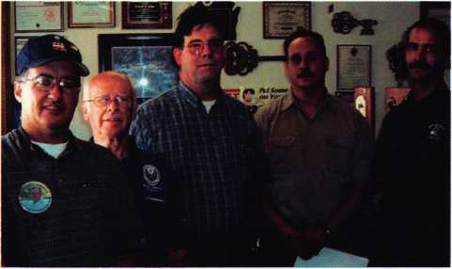

Meeting to work on Wisconsin Licensing  
Left to right: Ken Briggs, Bill Smith NC Director, Jeff Burby,  
Joe Kiewit, Dave Pettis

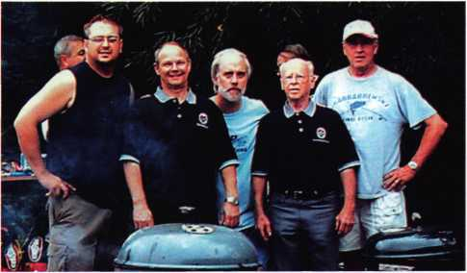

Annual Brat Fry

Pictured: IDN Distributing Work Crew with  
John Soderland, Secretary and Bill Smith, NC Director



THE CUBIC

PERSPECTIVE

By Dean Nickel, CJIL, CPL

After years of looking at master key systems I was shown something in a wonderful class by Harvey Arkawy, A.A., of Rabbit Soft and an "Advanced Master Keying Skills" book by Don O’Shall and John Truempy. These brought something to my attention that I had never really truly considered the concept of three dimensional masters.

I have always known that a lock keyed to 2 different keys has 30 other keys that will operate it within a 3 pin system, but until now I had never looked for them all. The book just kicked the last piece into place and made it all make sense. Thank you Harvey, Don and John!

The basic concept is that there is more than one mas­ter of the same level fitting the same change key in a standard (SPF) Charts. Jerome Andrews had outlined this as a “Parallel Master”. It is because they are made all at the same time in the system as chart is created. They are an intersection of masters or Intersecting Masters. Simply put, it is where more than one master key(s) operation cross at a change key or a small por­tion of change keys but they both don’t operate the same change key(s) entirely. Up to now this is not called out as such.

The way that was easiest for me to think about this was a Rubiks cube that is 256 panels on each side but with keys instead of squares. By knowing this you have more than one master crossing the same key, but with other changes keys we could bring in without interchange between masters or change keys. In the cube we have keys that are not the squares but between them. They are able to affect a select few squares due to their position in the cube. These keys that are between the others are the sub-master keys and can affect a few keys like a first level key or large portion of the cube like a third or higher level master key.

To make the example easy to see what is going on with the system (SPF) chart I made the master 00000 for its cuts in the example chart. In a real system you would never make it like this but the principle will be seen easier by this example. Also there are parts that have been replaced from a normal chart so you can see the relationship between the first block on the first four pages. The first key in the first page first block is 22468. There are three master keys 02468, 20468, and 22408 that would be the first level masters that could all operate this one change key as seen in the

**li**

Keynotes • October 2006

**Top Master Key**

|  |  |  |  |  |
| --- | --- | --- | --- | --- |
| 0 | 0 | 0 | 0 | 0 |
| 2 | 2 | 4 | 6 | 8 |
| 4 | 4 | 6 | 8 | 2 |
| 6 | 6 | 8 | 2 | 4 |
| 8 | 8 | 2 | 4 | 6 |

A C B E D

BASE FIELD (KBA)

KEY BITTING ARRAY

SEQUENCE OF PROGRESSION

0 2 0 6 8

VERTICAL MASTER

0 4 0 6 8

VERTICAL MASTER

0 6 0 6 8

VERTICAL MASTER

0 8 0 6 8

VERTICAL MASTER

|  |  |  |  |  |  |  |  |  |  |  |  |  |  |  |  |  |  |  |  |  |  |  |  |  |
| --- | --- | --- | --- | --- | --- | --- | --- | --- | --- | --- | --- | --- | --- | --- | --- | --- | --- | --- | --- | --- | --- | --- | --- | --- |
| i | | 2 | 2 | 4 | 6 | 8 | 17 | 2 | 4 | 4 | 6 | 8 | 33 | 2 | 6 | 4 | 6 | 8 | 49 | 2 | 8 | 4 | 6 | 8 |
| 0 0 4 6 8 | 2 | 4 | 2 | 4 | 6 | 8 | 18 | 4 | 4 | 4 | 6 | 8 | 34 | 4 | 6 | 4 | 6 | 8 | 50 | 4 | 8 | 4 | 6 | 8 |
| HORIZONTAL MASTER | 3 | 6 | 2 | 4 | 6 | 8 | 19 | 6 | 4 | 4 | 6 | 8 | 35 | 6 | 6 | 4 | 6 | 8 | 51 | 6 | 8 | 4 | 6 | 8 |
|  | 4 | 8 | 2 | 4 | 6 | 8 | 20 | 8 | 4 | 4 | 6 | 8 | 36 | 8 | 6 | 4 | 6 | 8 | 52 | 8 | 8 | 4 | 6 | 8 |

02468

BLOCK MASTER

0 4 4 6 8

BLOCK MASTER

0 6 4 6 8

BLOCK MASTER

|  |  |  |  |  |  |  |  |  |  |  |  |
| --- | --- | --- | --- | --- | --- | --- | --- | --- | --- | --- | --- |
| 5 | 2 | 2 | 6 | 6 | 8 | i | 2 | 2 | 4 | 8 | 8 |
| 6 | 4 | 2 | 6 | 6 | 8 | 2 | 4 | 2 | 4 | 8 | 8 |
| 7 | 6 | 2 | 6 | 6 | 8 | 3 | 6 | 2 | 4 | 8 | 8 |
| 8 | 8 | 2 | 6 | 6 | 8 | 4 | 8 | 2 | 4 | 8 | 8 |

0 8 4 6 8

BLOCK MASTER

Page 2 first block

0 2 6 6 8

BLOCK MASTER

0 2 4 8 8

BLOCK MASTER

|  |  |  |  |  |  |  |  |  |  |  |  |
| --- | --- | --- | --- | --- | --- | --- | --- | --- | --- | --- | --- |
| 9 | 2 | 2 | 8 | 6 | 8 | i | 2 | 2 | 4 | 2 | 8 |
| 10 | 4 | 2 | 8 | 6 | 8 | 2 | 4 | 2 | 4 | 2 | 8 |
| 11 | 6 | 2 | 8 | 6 | 8 | 3 | 6 | 2 | 4 | 2 | 8 |
| 12 | 8 | 2 | 8 | 6 | 8 | 4 | 8 | 2 | 4 | 2 | 8 |

Page 3 first block

0 2 8 6 8

BLOCK MASTER

0 2 4 2 8

BLOCK MASTER

|  |  |  |  |  |  |  |  |  |  |  |  |
| --- | --- | --- | --- | --- | --- | --- | --- | --- | --- | --- | --- |
| 13 | 2 | 2 | 2 | 6 | 8 | i | 2 | 2 | 4 | 4 | 8 |
| 14 | 4 | 2 | 2 | 6 | 8 | 2 | 4 | 2 | 4 | 4 | 8 |
| 15 | 6 | 2 | 2 | 6 | 8 | 3 | 6 | 2 | 4 | 4 | 8 |
| 16 | 8 | 2 | 2 | 6 | 8 | 4 | 8 | 2 | 4 | 4 | 8 |

Page 4 first block

0 2 2 6 8

BLOCK MASTER

0 2 4 4 8

BLOCK MASTER

**2**

Keynotes • October 2006

LINE MASTERS

20468

4 0 4 6 8

6 0 4 6 8

8 0 4 6 8

Block masters thru first 4 page 2 2 4 0 8

4 2 4 0 8

6 2 4 0 8

8 2 4 0 8

Cube master for first block 4 pj

02408

example cube #1. The last master key is the one you would not see normally as this one spans 4 pages and most people would not chart this key. If you didn’t need this key, you can still not chart it. Knowing that it exists is the important part and how to use it.

|  |  |  |
| --- | --- | --- |
| Board | A | 00000 |
| Administration Department | AA | 02468 |
| Finance Department | AB | 20468 |
| Research and Development | AC | 22408 |

|  |  |  |  |
| --- | --- | --- | --- |
| Door | Lock | Keying | Note |
| 100 | VD 99 Rim | XAA1 -22468 | O/B A, AA, AB, AC |
| 101 | L9050 | AA2 - 42468 | Admin Offices |
| 102 | L9050 | AA3 - 62468 | Admin Offices |
| 103 | L9080 | AB1 - 24468 | Finance Offices |
| 104 | L9080 | AB2 - 26468 | Payroll Offices |
| 105 | L9080 | AC1 - 22488 | R&D Lab |
| 107 | L9080 | AC2 - 22428 | R&D Lab |
| 110 | L9080 | AC3 - 22448 | R&D Offices |

Where this comes in handy is if you had a customer that needs a top master, three department sub-mas­ters and a change key that the three sub-masters will operate. Each department needs two or three other change keys but these change keys don’t fit the first door.

This can be done with only first level masters or masters that are only one cut in common with the top master. The system can be entirely within the first line of blocks of the first 4 pages of the standard (SPF) charts. We just have to find the AC Master and that is easy to do as you can see in the example chart. This last mas­ter is a block master that runs down thru the top 4 pages. It operates that first key in the first block on those 4

pages.

We reduce the amount of pins and cuts in a lock, but make good use of the keys that are in a system which we don’t normally see. As seen by the last master in use above because we can’t see them in the standard (SPF) charts that we write. You would need to make a 5 th page for every 4 in a standard (SPF) chart. This would be only masters that affected the last 4 pages before the 5th page. It would list block and other masters but for the third dimension that is not listed in the other 4 pages.

So this is about how to utilize what we have in a system more than how to make a system. It is how we look at the master key system that is the trick. It is not a simple thing to look at something in three dimensions if you write it a two dimensional manor. If you can make a standard (SPF) master key chart, then you know how to make everything you need for this topic of study. If you don’t I would strongly urge you to get into a good class on basic master keying. I must warn you that it will take years of study to fully under­stand the basics of master keying.

But it is fun to learn.

The first thing in seeing how this relationship works is example cube #1 show’s a small portion of the larg­er picture. Here you see a cube that would represent the top blocks on the first 4 pages of the standard (SPF) charts. There are points along three lines, each line represents a first level master key and each point on

Keynotes • October 2006



the line represents a change key. The three masters  
cross the first key but also have other keys that they  
operate but not by the other two masters. Therefore  
you can use this one key for the front door (XAA1)  
and the other change keys for other doors without

worry of interchange.

All three masters (AA,

AB, & AC) will work  
the one door. This  
will allow you do  
what the customer  
has outlined without  
destroying more of  
the system with the  
addition of master  
pins in any chamber.

Maison keying has  
destroyed more sys-  
tem potential than  
almost any other sin-  
gle thing other than  
uneducated techni-  
cians trying to make  
systems they are not  
qualified to make. Just the  
addition of a single master

pin to a lock will add a multiplier. Let's say that you  
add one master pin to a 5 pin system, you would have  
48 keys instead of 32. You can see the danger of  
adding pins. I will agree there are times you cant get  
away from it but with proper planning and education  
this can be greatly reduced.

If you need more change keys under a master you

just have to step up to the second level master or two  
cuts in common with the top master to get 12 extra  
keys. Essentially the idea is the same. So instead of a  
block or line master you would use a horizontal mas-  
ter in red, vertical master in green and a cube master

in blue each with 16  
keys but with only 4  
keys operated or shared  
between the 3 master  
keys instead of just the  
one change key like  
found in the first level  
masters. Again there is  
nothing added to each  
lock in the way of mas-  
ter pins to destroy key-  
ing potential and we  
have increased what we  
can use.

Please note that the  
cube master has never  
received a name until  
now in any book. I have  
been able to find any  
reference to this master.  
It has always just been

another master.

As you can see this can get complicated quickly if you  
are not paying attention. The easy way to look at this  
is the lines that the master runs like in the example  
cubes. It runs so far and then stops. A first level mas-  
ter runs 4 keys and stops. A second level master runs  
4 lines wide, 4 deep and stops. A third level master

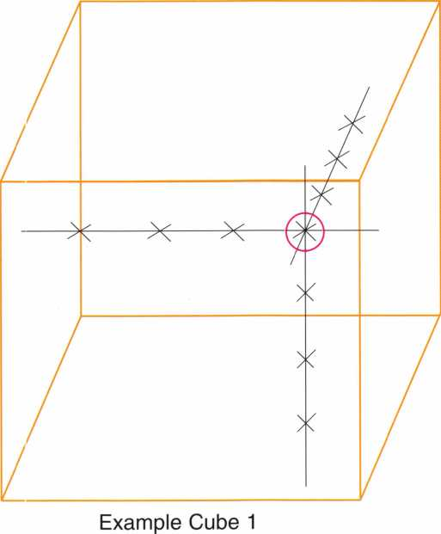

Keynotes • October 2006

runs 16 lines wide, 16 deep and stops. Simple if you remember to look for the relationships. There are many more masters than I have outlined here. The main thrust of this article is to have you start thinking in three dimensions.

The study of master keying is where finding these

masters and understanding how they can be used all comes together. The importance of any system is that you are aware what you can and cant do as part of creating a secure system without problems for you or your customer.

><><><x

/\

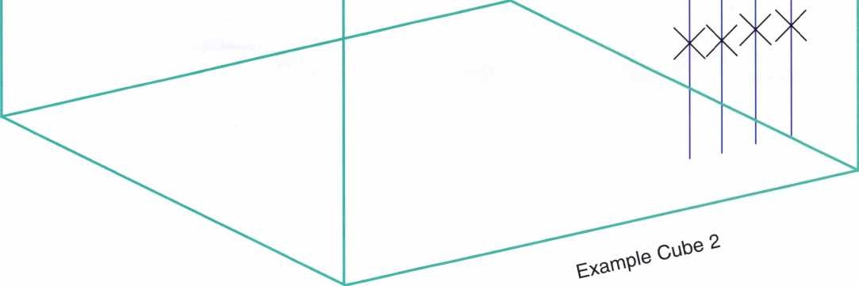

Keynotes • October 2006

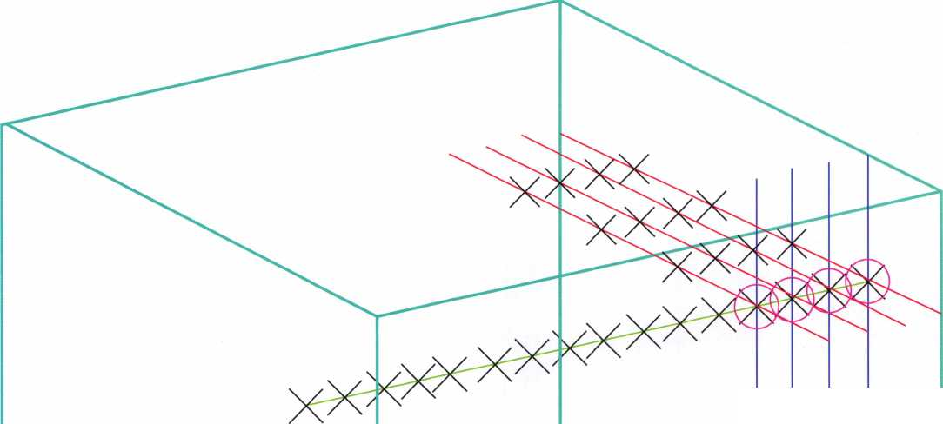

Look Ma - No Handle!

by Greg Perry, CML, CPS

This month we’ll look at a little different kind of opening. What do you do when the safe handle breaks off?

Usually its time to go fishing, only instead of using a rod and reel you need to bring scopes, wires and a little ingenuity. A friend on the Navy base next to us called to ask my advice on how to get this Diebold Class 5 GSA Map and Plan safe open, I had pictures of a similar safe, so I mused, why not join him for the fun?

Since this is a GSA container the only location approved to drill  
holes without removing the label is under the dial ring.

Anyplace else requires prior approval from the folks at the DOD  
lock program along with and great documentation of your repair  
and including reasons why you needed to drill outside the dial  
ring area. Or if you are a GSA inspector you can go back to

your instructor for approval. I’ve only needed to drill a hole  
outside the dial ring area once. It was on a vault door and I was  
able to get approval because the problem was in the boltwork.  
This model safe is no longer made, nor are parts available.

Since the handle was broken it probably would not go back into  
service but there’s always a chance finding parts on the used  
market or perhaps from a similar safe junked for a different rea-  
son. No need to drill a hole in this safe though, we have the  
handle hole into the area we need to work.

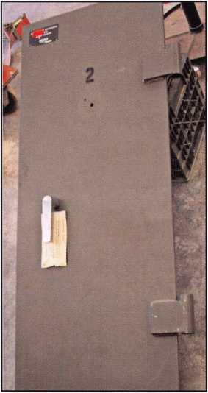

A few of the pictures  
from this job did not  
turn out the best so  
I’ve added some of the  
pictures used to get  
this one open. Photo  
1 shows our safe with  
the missing handle.  
Photo 2 is from my  
picture collection of a  
similar door without  
the body that a cus-  
tomer brought in for  
servicing. The first  
thing you’ll note from  
the pictures is this safe  
has a two stage bolt  
work.

Photo 1

Photo 2

**6**

Keynotes • October 2006

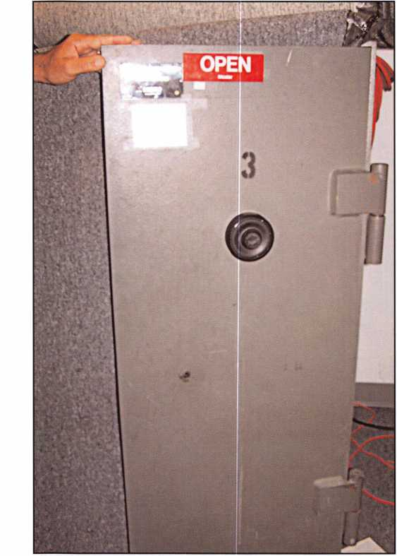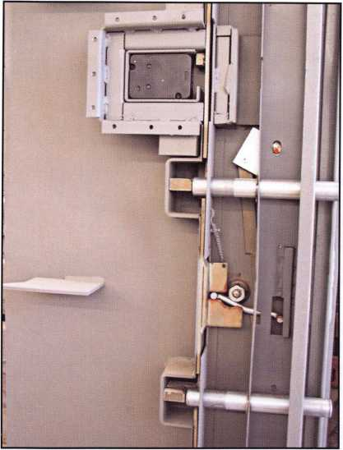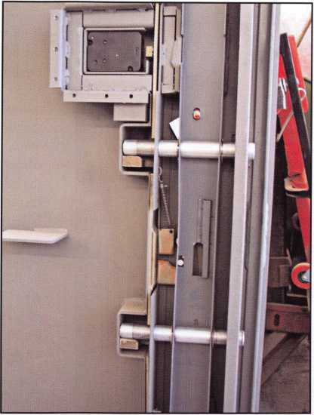

Photo 3  
shows a good  
view of the  
block that is  
designed to to  
prevent  
punching.

Photos 3

Photos 4

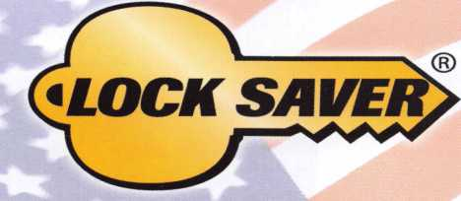

LUBRICANT PROTECTION  
FOR ALL LOCKS

World’s Finest Synthetic Lubricant

Long Lasting Lubrication & Protection

MADE IN THE USA

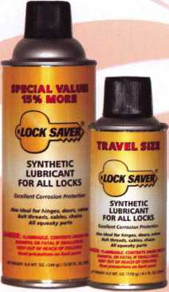

* Environmentally Safe, Non-Toxic
* Will Not Gum Up or Clog Up
* For All Lock & Key Combinations
* Will Not Attract Dirt, Water or Debris
* Works Well in All Climates
* Temperature Range: -65°F to +450°F

Ml-l

**to**

Mil-Comm Products Company, Inc.

TOLL FREE: 800.743.4518

Visit Our New Website: [www.mil-comm.com](http://www.mil-comm.com)

Keynotes • October 2006

Photo 5

It moves down from behind the bolts in photo 4 allowing the bolts to retract. Drilling a hole to punch back the boltwork back or laying the safe on it’s side will not work. The other part that complicates this opening is the addition of a spring that lifts the boltwork up, keep­ing it in the locked position. We tried pulling down on the boltwork with various hook tools made from bent coat hanger wire, welding rod, and music wire but the spring was a little too strong, or so we thought.

Photo 6

**8**

Keynotes • October 2006

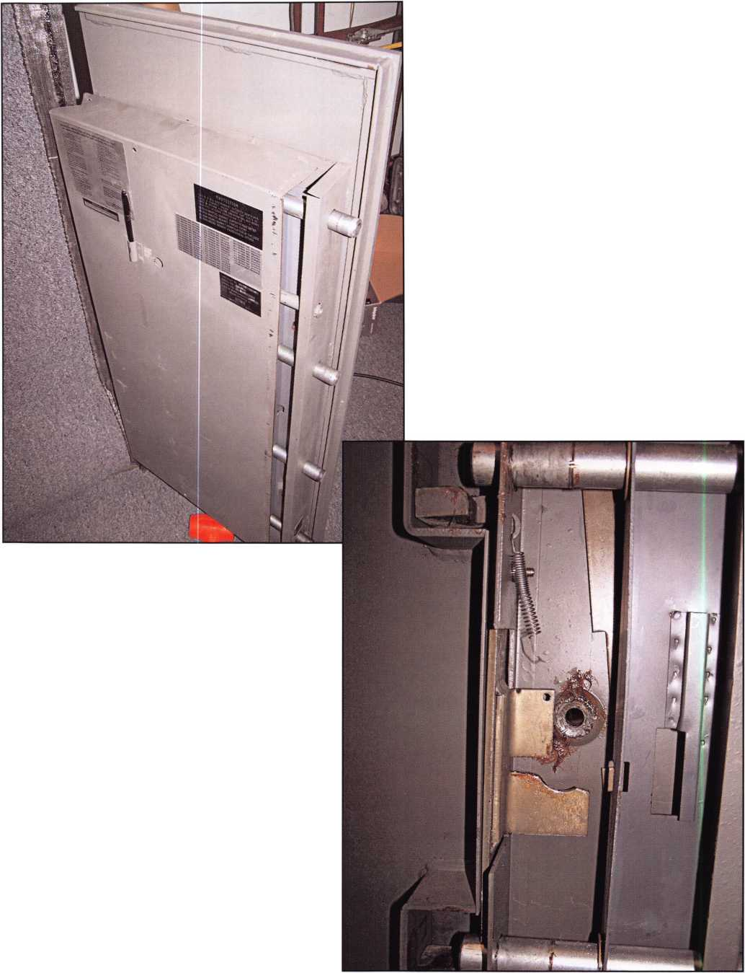

This year  
we’re back in  
LEXINGTON  
for the 150th  
Anniversary  
of Sargent &  
Greenleaf.

***THE RACE STARTS HERE***

**Keeping up with the latest the industry has to offer has never been this important - or this FUN! When it comes to learning about the latest in safes and vaults, time is of the essence. SAFETECH 2007 fea­tures an all-new menu of classes, covering every safe topic on the globe.**

***OUR SAFETECH 2007***



***SPONSORS!!***

**SARGENTANDGREENLEAF**

**SAFETECH**

LEXINGTON’S

**READY.**

**ARE YOU?**

**MARCH 5th thru MARCH 10th, 2007**

**LEXINGTON**

**KENTUCKY**

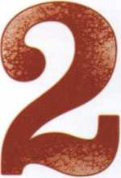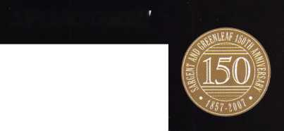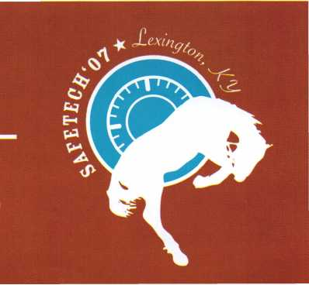

Time for Plan B...

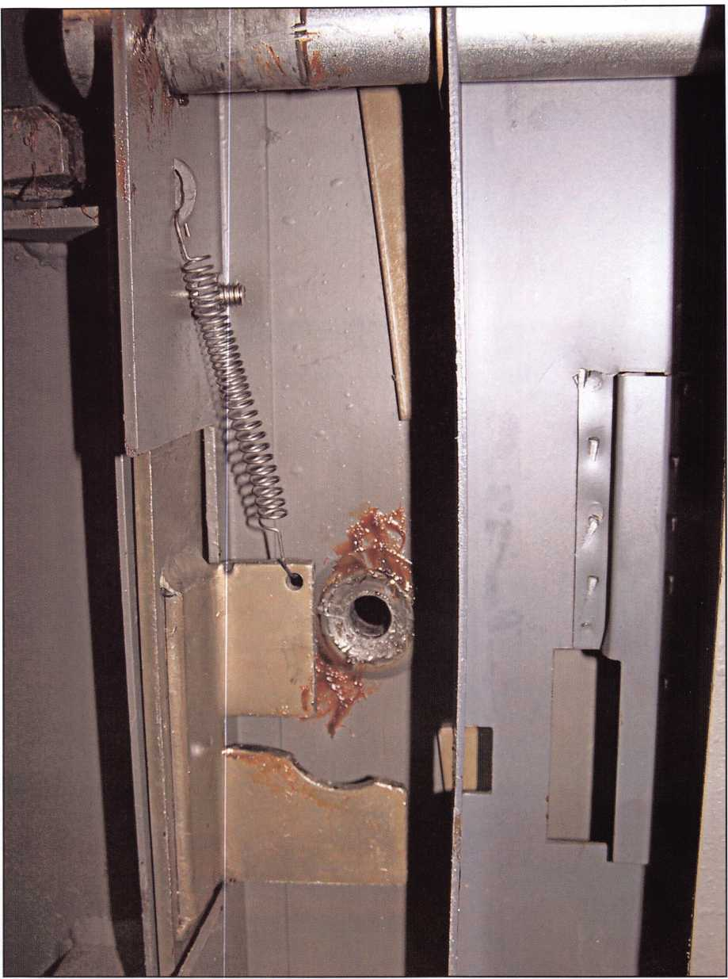

Photo 7

Keynotes

October 2006

Time for plan B, if the spring wont let us pull the boltwork down then perhaps we need to remove the spring formfrom the boltwork. Fortunately the spring is close to the handle hole. Reaching in with a strong music wire we were able to pull the spring off the boltwork.

Next we tried to pull the boltwork down. It still would not budge until we vibrated the door a little with a dead blow hammer. Once the safe was open we found the boltwork in need of a little lubrication, this explains why we were unable to pull it down with our hook tools.

Photo 5 shows the back sliding off. It was very tight and required a lit­tle persuasion to get it off. Photos 6 and 7 show the spring disconnect­ed and also the way it should look installed.

Some openings are straightforward: either manipulate or drill a hole, scope it and open the door. Others can be a little more challenging like this one. The ones that are best are the ones that challenge you and make you become a better technician.

You need it When?

**How about now!? :-)**



Another Special  
Value-added Benefit to your

ALOA Membership! Click here

l*L*

www. c I ea rsta r. co m / A LO A

**Professional Business Products**

Invoices Tags *Call for a free*

Checks Key Fobs *brochure and samples*

**Business Magnets 1-800-355-6322**

Cards Labels [www.pbp2000.com](http://www.pbp2000.com)

CLAIM CHECK

YOUR FIRM NAME HERE

123 Main Streel

YOUR TOWN, STATE AND ZIP

Phone 123-4567

Keynotes • October 2006

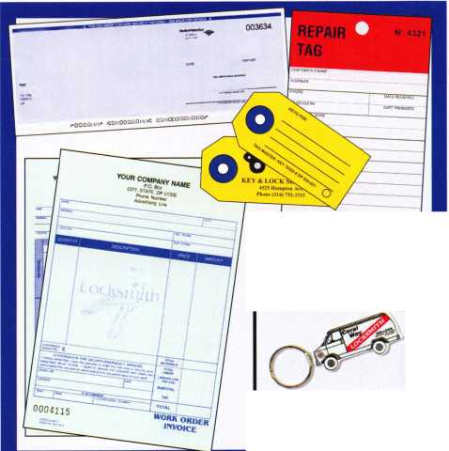

By: Claire L. Cohen, CML

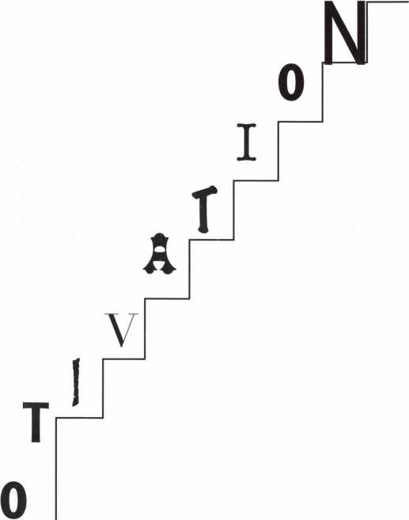

n

Motivation has been defined as the mental process that gives behavior purpose and direction. It is the inner force that drives individuals to accomplish personal and business goals with energy and persist­ence. In the workplace it is a passion for work that goes beyond money or status.

Survival in our industry is dependent on our own motivation and every employee in our business. In our rapidly changing security field, motivated employees will enable our businesses to be more pro­ductive and grow.

Setting a positive example of a motivated manager or supervisor is a major role. To be effective “the boss” needs to understand what truly motivates employees in the job(s) that they per­form. Understanding what motivates every member of the staff is the most com­plex function of a supervi­sor. Motivators are differ­ent for each employee, and motivation may change over time.

Motivating employees starts with motivating yourself. A great place to start is to understand your own motivators. The key to helping to motivate your employees is to understand what motivates them. So

what motivates you? What can you do to better moti­vate yourself?

Set the example. You must be the role model that you want others to grow into.

Enthusiasm is contagious.

If you're enthusiastic about your job, it's much easier for others to be, too. If you're doing a good job of taking care of yourself and your own job, you'll have much clearer perspective on how others are doing in their job.

A key to supporting the motivation of your employees is to recognize their importance to the business. Employees are motivated more by your care and concern for them than by your atten­tion to each specific task they perform.

Any steps taken to support the motivation of employ­ees should include finding out what it is that really motivates each person you manage. Meet with each of the people you supervise to learn what they think are the most important moti­vational factors to them and by observing them. People are motivated if they think they are capable, feel competent in doing their job, and if they believe their efforts are being rewarded fairly. “Reward”

*

Keynotes

October 2006

Simple to use, install, and maintain. Basic digital entry as  
simple as a single stand alone digital keypad for economical  
applications - or programmable digital keypads with access  
for hundreds of users and multiple doors and/or gates.

Complete systems that can include electric locks and  
access control devices linked to weigand control boards -  
all manufactured by DKS.

* Durability - backed by more than

50 years of Made-in-the-USA Jpi

manufacturing and expertise

* Outdoor use in all weather
* Easy to install magnetic  
  locks for both doors and  
  gates - a full line available  
  from 300 - 1200 lbs  
  holding force
* Vandal resistant - DKS

keypads feature:  
stainless steel  
faceplates, galvanized  
steel sub-plates, and  
rugged steel cabinets

Push Butfcsm

To Call

We use DoorKing because they have a full line of products which provides us with one-stop shopping and they have a great customer service department.”

*Scott Brose, Bejan Souferian* Co-Owners, Scotland Entry Systems, Inc.

Van Nuys, California

ACCESS CONTROL SOLUTIONS

for over fifty years

**surface mount**

**Locking and Entry**

**single and multi-door access control**

**flush mount**

**magnetic lock**

*■mm*

—

**1504 with intercom**

**Designing and Manufacturing a full line of product since 1948**

**Gate Operator**

**Telephone Entry**

**Parking Control**

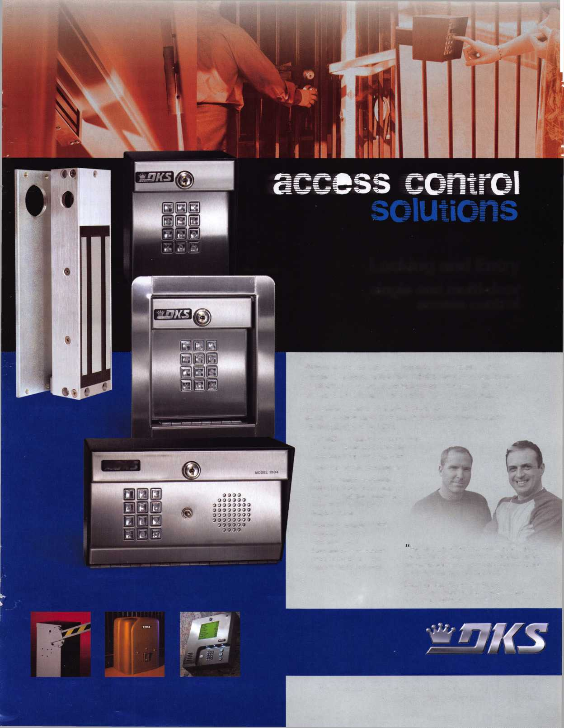

may include monetary compensation; however compensa-  
tion is not limited to money alone. I may include such  
things as sponsoring their further education through train-  
ing classes, paying for association memberships, promotion  
and/or to be included in decision-making processes.

Give them a challenge! Make each business member s  
task challenging and meaningful. Make each feel like an  
individual in a great team...rather than a cog  
in a lifeless machine. People need mean-

ingful work. Every member  
of the team needs to know that  
they are valued and that their  
function is important and nec-  
essary for the survival  
of the business.

Treat each member of your  
business team with respect.

The golden rule still applies.

Keep everyone informed.

Keeping the communication  
channel open allows a person  
to have a sense of control over  
their lives.

Allow your team to be part of the planning  
and problem solving process. Including every mem-  
ber of the organization makes them part of the team.  
People who are part of the decision making process  
become the owners of it, and it gives them a personal  
interest in seeing the plan succeed. Communication is  
clearer as everyone has a better understanding of what role

they must play as part of the team. Next, it creates an open  
trusting communication bond. They are no longer just the  
doers for the organization — they are now part of it!

Reward good or outstanding job performance. Although a  
gift certificate, letter, or a personal “thank you from the  
boss” may seem small and insignificant, they can be power-  
ful motivators. The reward should be specific and prompt.  
Do not say something general, such as "for doing a good  
job," rather mention the specific action that made you

believe it was indeed a good job. In addition, help those  
who are trying, but need a little assistance. We all  
make mistakes or need help on an occasion

to achieve a particular goal.

Let employees hear positive feed-  
back from their customers to  
understand the benefits of their  
efforts for a task well done.  
Reinforce this to show value to  
your entire business.

Clearly convey how employee  
results contribute to total busi-  
ness success.

Employees often feel strong  
fulfillment from realizing that  
they’re actually making a difference.

This realization often requires clear com-  
munication about business goals, employee  
progress toward those goals and celebration when the  
goals are met

In the security industry, or any other business, employee  
motivation is a process, not a task. Businesses change all  
the time, as do people. It is an ongoing process to sustain a  
business environment where each employee can strongly  
motivate themselves. If you look at sustaining employee  
motivation as an ongoing process, then you will be much  
more fulfilled and motivated yourself.

A key

to supporting

the motivation of  
your employees  
is to recognize their  
importance to the  
business.

**24**

Keynotes • October 2006

Stop giving your profit to carpenters and lumberyards!

**If you don’t keep one on  
your truck, you can’t  
answer the call**

**Save time, make more money and sell better locks**

**Because You Can’t Afford False Security ®**

**Don’t waste your repairing a broken J**

Standard

Set

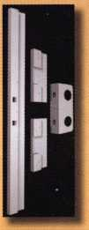

Fits doors with  
standard lock  
spacing

Universal

Set

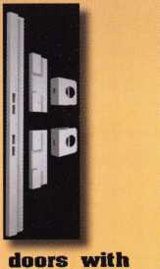

Four-piece steel system secures existing entry doors

Fix broken doorjambs and secure your hinges  
without removing the door

Can be installed in under an hour and painted  
to match the door

Door Shield Hinge Shield

Reinforcing one point on a  
door means that others will  
break when the door is kicked.

Door Jamb Armor reinforces I Fits

several key weak points... | non-standard

...This is a fix, not a patch | lock spacing

Home security that actually works...Before intruders enter!

**[www.djarmor.com](http://www.djarmor.com) 1-888-582-2294** Wa **«**

Recommend *»

TM

© 2005-2006 A&G Security LLC. All rights reserved. Dow Jamb Armor and Because You Cant Afford False Security are trademarks of A&G Security LLC.

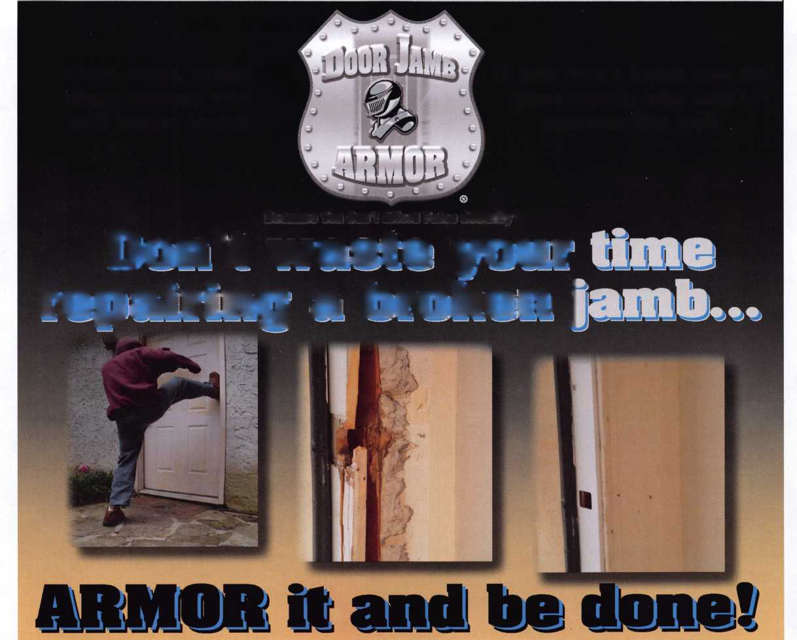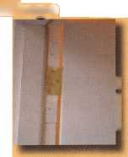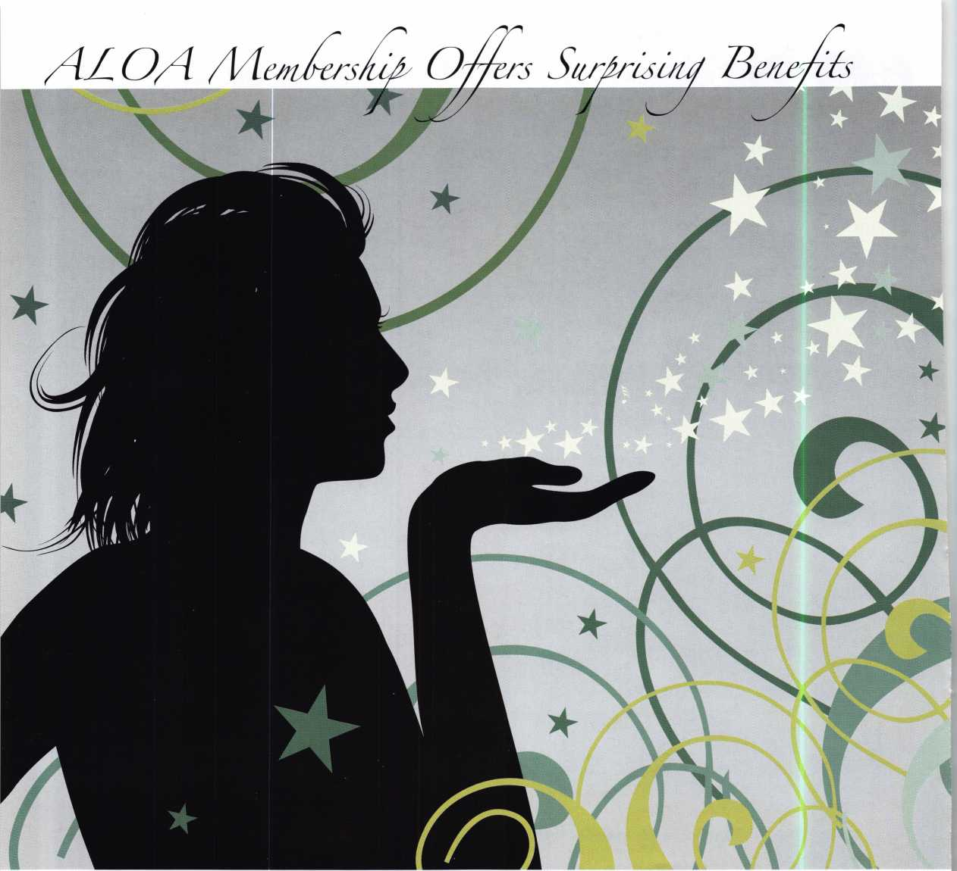

byT.F. Stern

I had a lock job close to downtown the other day, close enough where I could stop by and visit with my old friend Jim Reed, the fellow who started me down the road to become a locksmith. We had a good visit as he chided me for having mentioned him in some of my previous writings. Jim was a good teacher and taught more than how to make a key; teaching about politics and where the industry was headed, that was back in the mid 70s and he was correct in almost all his predictions.

3 Keynotes • October 2006

Jim was, at the time, and continues his membership, in the Associated Locksmiths of America and wanted me jump on board. I think there was a deal where if you got somebody to join ALOA your next years membership was reduced or maybe even free. He explained what the membership dues covered; a monthly Keynotes Magazine with all kinds of helpful tips, legislative updates and last; but not least, the added benefits of having “Key Fairies” to help along the way. He’d laugh and wink, a sly grin graced his face as his East Texas accent pulled me along; his wry sense of humor was

**2**

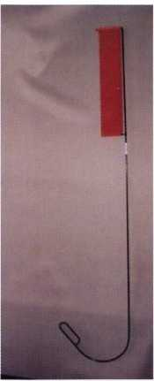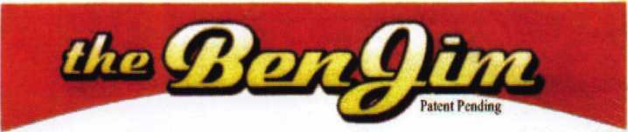

Emergency Door Opening Tools

AS SEEN AT THE 2006 A.L.O.A CONVENTION

All commercial buildings have two things in common:

* Fire code requires that all commercial locks open by a single action.
* The American Disability Act requires free access through doorways,  
  which leaves a gap between the door and the floor.

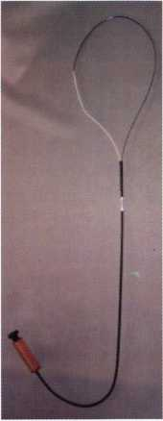

Knoblock Tool

Leverlock Tool

WITH THIS IN MIND WE HAVE DEVELOPED THE TOOLS REQUIRED TO EFFECTIVELY  
OPEN DOORS QUICKLY AND WITHOUT DAMAGE

Designed for interior commercial doors

For knoblocks, the tool is slid under the door with no cords to pull or get tangled.

For leverlocks, a similar tool is used by applying the same method of sliding the tool under the door and pull until the lever retracts.

Both tools are designed to work with very little effort, excessive force is not needed.

Visit our web site at [WWW.THEBEN-JIM.COM](http://WWW.THEBEN-JIM.COM) for more details.

THE BEN-JIM KNOBLOCK TOOL $ 99.00

THE BEN-JIM LEVERLOCK TOOL $ 79.00

SET (one each) $169.00

PLUS SHIPPING & HANDLING

**TO PLACE AN ORDER CALL 1-586-778-1911 OR VISIT US AT [WWW.THEBEN-JIM.COM](http://WWW.THEBEN-JIM.COM)**

MADE IN THE U.S.A BY THE BEN-JIM CORPORATION.

*

24711 Harper Ave. * St. Clair Shores

MI * 48080 * (Fax) 586-778-0530



* Keynotes, the official publication of ALOA, brings you the industry news you need to aggressively face the challenges of business in the security industry. You get technical information, management insights, education­al resources, an industry calendar of events, legislative reports and other association news. Keynotes helps you stay on the cutting edge of business and security technology.
* New Business: Your listing at findalocksmith.com identifies you as a qualified and responsible industry professional. Listed first on a Google search, Findalocksmith.com is the leading source for consumers looking for

your services.

* Discounts: ALOA members receive special discounts on services, educa­tion, supplies, the annual convention and more. ALOA works to improve your "bottom line" in every way.
* Management & Marketing Services: As an ALOA member you benefit from the availability of management tools and advisories designed to give you that edge. All participating members get these valuable tools and ongoing periodic updates and reports to sharpen their business and marketing skills.
* Free Bonding: Available to Active Members in the United States and Canada after completing a 90-day probation period. New Active Members will be mailed a bond application in their new member pack­et, which is mailed after the 90-day probation period.(Apprentice mem­bers are not eligible until after the apprentice period with ALOA is com­plete.)

» ALOA is Your Legislative Alert: ALOA takes an active role in helping to interpret proposed or enacted laws and regulations which affect you. ALOA stands as a single voice for thousands and moves quickly to pro­vide legislative advisories. ALOA monitors legislation for the benefit of locksmiths and is active in national lobbying on your behalf.

► Grassroots Participation Through Chapters: Association members receive ALOA products and services through a growing network of chapters. With Chapters worldwide, ALOA members can grow person­ally and professionally through local involvement.

' Scholarships: ALOA members are eligible for scholarships which offset costs of education for locksmiths who might otherwise not be able to participate. *

* ALOA Staff: Just call. The ALOA staff is always ready to help you, what­ever your question may be. In addition to offering a full range of servic­es, programs, products and money-saving opportunities to meet your needs, our number one goal is to help assure continuous growth and development for you and your business.

equal to his locksmith

skills.

“Key fairies have  
to follow the  
rules too, ya  
know. They’re  
honor bound;

no stealing

keys or  
any-

that. They are;

however, permitted to place the corner of a  
newspaper on top of a set of keys that are on somebody’s desk,  
flick them in the trash or let them fall into a pocket so’s the  
owner of those keys thinks they’re lost.” Jim would smile,  
always a big grin as he went along, following the wonderful  
explanation of how locksmiths who are members of ALOA  
have these added ways to earn a living.

Once in a while a customer will ask me why a particular job is so expensive. I’ll point to a list hanging in mid air, going down each item; cost of a transponder key blank, time to determine the mechanical cuts, the expensive computer used to program the onboard systems, license fees to the State of Texas and lastly, ALOA dues which include a small portion set aside for the Key Fairies. I try my best to emulate Jim Reed’s East Texas humor and have some fun with all my customers.

Speaking of fairies, Last year’s tomato garden may have been my very best ever. The plants grew thick with tomatoes that were large and sweet. I enjoy a vine-ripened tomato sliced with a touch of salt; not much can beat the flavor. Each year I take a few photographs to compare with prior crops. In this way, long after the last tomatoes has been eaten I can remember with a certain amount of satisfaction, having grown them in my back yard and look forward with renewed anticipation, the warmth of spring and yet another chance to plant more. It wasn’t until the other day that I discovered the reason for their success; tomato fairies.



Keynotes • October 2006

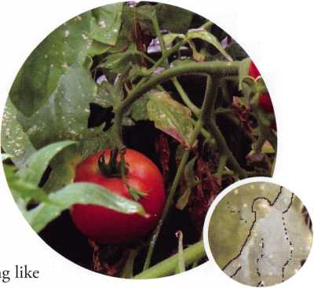

No, I haven’t been re-visiting the 60s and I haven’t taken a pain pill for my back in over a week. Like I said, I took pictures of my tomato plants; the best pho­tograph I’ve been using on my computer as wall paper behind all the icons. This past week I was cleaning up the desk top, getting rid of some unused program icons which left a hole, as it were, in the middle of the desk top icons. More of the tomato plant picture could be seen, an area that heretofore I had ignored, my interest had been focused on the huge tomatoes.

It now showed a part of the plants that were mostly leaves, off to the left of the part that had the tomatoes. There, caught in the moment, mixed in with the lush green of the tomato plant leaves; was a clear and distinct image of a tomato fairy. She must have been flying in and out doing her magic at the very moment I took the picture; her wings outstretched as the reflection of the blue sky danced on them.

Not being an expert on tomato fairies, I have to assume that the one in my picture must be a female fairy; either that or male fairies wear long gowns too. Her translucent figure blended in so well with the leaves as to render her nearly invisible. If it had not been for the sparkling of fairy dust near her head I would never have picked her out of the background. There was no denying her presence, the light blue wisp of gown as it gently floated above the plant, her face rising with the glow of tiny luminescent orbs to light her way. I showed the picture to my wife; but she insists that my imagination has run away with me, that the image is the product of two leaves of varied hue and nothing more.

In my thirty years as a locksmith I have never once seen a Key Fairy; all the same I have no doubt that they have helped my business to grow. I renew my membership with ALOA without fail and know that it’s a good investment. My wife can go on about how I’ve let my imagination get the best of me or how the leaves make it appear or give the illusion of something that might look like a fairy. To see such things one has to have the faith of a child, regardless of age. I remem­ber my mother telling me how she took a fairy from Staten Island across to Manhattan when she was young. What more need I say?



changes for 2007. This year, we have listened carefully to YOUR SUGGESTIONS and we are rapidly making changes to suit your needs.

* Don’t miss out as we roll out our new- and-improved Keynotes magazine intro­ducing such interactive features as a Q&A section exclusively for members.
* More user-friendly ALOA website.
* More training & education opportunities.
* Better and broader network possibilities.
* ALOA store with more books & better merchandise; NEW products that help YOUR bottom line.

RENEW TODAY to become eligible for great prizes including an exciting 7-day cruise!

ALOA offers you the strength of over 8,000 leading firms & individuals. ALOA is YOUR voice in the industry and represents the collective interests of the association to the press, govern­ment, and the public. Let us continue to open doors for you!

Keynotes • October 2006

New Products: Blue Wave Security Announces Successful Launch of Open Standard Wi-Fi Access Control Solution

Austin - September 19, 2006 — Blue Wave Security, The Wi-Fi Lock and Security Company, announces the successful launch of an end-to-end physical access control solution based on the IEEE 802.11 (Wi-Fi) wireless standard. The company, along with distribution partner, Clark Security Products, has complet­ed initial rollout and pilot phases of the Blue Wave Security solu­tion to the security dealer channel. Building on this momen­tum, Blue Wave is conducting a two-month, twenty city, nation­wide series of dealer training sessions, reaching hundreds of secu­rity dealers and integrators. Blue Wave Security will also be fea­tured in the Clark Security Products booth at the ASIS trade show in San Diego, September 25th-27th, and featuring the next generation of access control.

"In the months of June, July and August, BlueWave Security trained and certified approximately 15 dealers in Texas and California to install the BlueWave access control solution,” said Mance Harmon, Founder and CEO of BlueWave Security. “These dealers have installed our product on dozens of doors with absolutely no technical problems or failures. As a result, BlueWave Security has very satisfied customers placing subse­quent orders.”

“We are honored and excited to be the first distributor, training base and sales support for BlueWave Security to security dealers across the U.S.,” said Marshall Merrifield, President and CEO of Clark Security Products. “We are pleased at the significant response from our initial training and the opportunity to provide a cost savings access control system to our customers.”

“Dallas Baptist University (DBU) required a cost effective upgrade to our access control security system,” said Charlie Bradley, Maintenance Supervisor of DBU. “The BW solution is non-proprietary, easily connects to our Wi-Fi network and is half the price of a wired system.” “DBU is very pleased with the results and will continue to deploy the BlueWave Security solu­tion across our campus in the coming months.”

BlueWave has successfully entered the security market with the BlueLink Wi-Fi controller, BlueView access control software, an established national service group and distribution channel to support if s next generation access control solution. BlueWave s panel-less system works with any standard industry locking device or electronic card reader using secure wireless communica­tions, and substantially reduces installation costs by eliminating long, home run wire pulls. Product packages are available for both small to medium sized businesses (SMB) and enterprise- class customers across a vast array of industries including: Commercial, Government Municipalities, Healthcare, Industrial, Institutional, Retail and Transportation.

BlueWave Security and INTELLIKEY Corporation Announce Partnership to Provide Ethernet and Wi-Fi Managed Mortise Locks

Announcing to the Security Market at ASIS 2006

San Diego - September 25, 2006 - BlueWave Security, The Wi­Fi Lock and Security Company, and INTELLIKEY Corporation announce a solution bundle comprised of the BlueView access control software, the BlueLink Ethernet or Wi-Fi door controller and the INTELLIKEY Mortise / Rim cylinder. The solution bundle enables standard mortise locks to be easily converted to centrally managed, access-controlled locks using the customer s existing Wi-Fi or Ethernet data network. The customer simply replaces the existing cylinder with the INTELLIKEY cylinder, connects the cylinder to the BlueLink controller and the BlueLink controller to the existing data network. The BlueLink Ethernet controller supports Power-Over-Ethernet, and therefore does not require an external power source. The BlueLink Wi-Fi controller uses the IEEE 802.11 standard for wireless communi­cations and supports both the WEP and WPA wireless security standards.

"BlueWave is delighted to be partnered with INTELLIKEY to provide an industry first, Wi-Fi and Ethernet-managed mortise cylinders,” said Mance Harmon, Founder and CEO of BlueWave Security. “BlueWave brings to the world of physical security the technology and expertise to enable a new generation of Wi-Fi and Ethernet-based access control. INTELLIKEY cylinders are specifically designed as replacements for most standard cylinder types. In partnership, these two technologies offer all the bene­fits of a fully-managed, access controlled door for half the cost.”

“This is a great opportunity to enhance the INTELLIKEY prod­uct line by combining our expertise in physical security and access control with proven communications technology to offer our customers superior capabilities at a price that wouldn’t have been possible just a few years ago,” said INTELLIKEY General Manger, Singh Chhatwal. “Were very excited about this partner­ship.”

The solution bundle will be distributed through Clark Security Products beginning in the fourth quarter of this year, and a demonstration of the solution can be viewed in both the INTELLIKEY and Clark Security Products exhibits at ASIS, hosted in San Diego, September 25th - 27th, 2006.

**30**

Keynotes • October 2006

New Products: NEW Kaba Access Control Parts Books & Kaba Access Control Products Compatible with Abloy Cylinders

Winston-Salem, NC (July 25, 2006)

Winston-Salem, NC (September 15, 2006)

With a continuing commitment to provide the most effective sales and service tools, Kaba Access Control is pleased to announce the release of two new parts books:

* Simplex Parts Price Book
* Electronic Locks Parts Price Book

In addition to the latest information on the parts and kits available for Kaba Access products, these books contain new pricing effective September 1, 2006.

Kaba Access Control is pleased to announce that the following products are compatible with Abloy Key-In-Lever Cylinders and Large Format Interchangeable Cores.

Cylinder Type Abloy Model Compatible Lock Series

Key-In-Lever Cylinder CY406N E-Plex 5000, Simplex 5000

Lge Format Interchgable Core..CY416N E-Plex 5000, Simplex 5000,

Simplex 1000, Simplex LI 000, Simplex LP1000, Simplex 8100

Kaba Access Parts Price Books are available Online at [www.kabaac-  
cess.com](http://www.kabaac-cess.com) - select “Product Literature”  
menu option. Books can also be requested by e-mail to  
[sgrant@kaa.kaba.com](mailto:sgrant@kaa.kaba.com) or by phone at 1-800-849-8324, extension  
232.

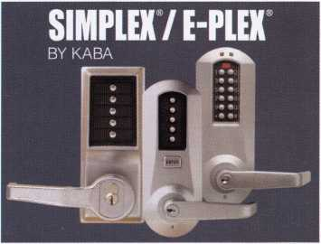

|  |  |
| --- | --- |
| VingCard |  |
| * Elsafe |  |
| Secure Your Future | |
| With the Market Leader in Electronic-Locking Systems | |
| : a ah B | L.Mi gl - |

**Qualified Locksmiths  
Wanted...**

We are looking for locksmiths to contract with to install  
and service our security solutions.

Large-scale installs, steady workflow and professional  
training are some of the many benefits provided.

Call: *(800) 225-8464 Ext. 3127*

VingCard Elsafe - 631 International Parkway, Suite 100 - Richardson, TX 75081 - Toll-Free: 800.225.8464  
Phone: 972.907.2273 - Fax: 972.907.2771 - E-mail: [noram@vcegroup.com](mailto:noram@vcegroup.com) - Internet: [www.elsafe.com](http://www.elsafe.com)

An ASSA ABLOY Group company **ASSA ABIDY**

IN-STOCK...MORE SAFES

***FREE Freight Program***

***(30 States)***

AMSEC FireKhg  
**fiaidall** HAYMAN  
MEILINK y/CTOR

**TURD tO**

**WHOLESALE SERVICE**

800-848-9790

Keynotes • October 2006

New Products: Medeco Introduces a NEW & Improved Maxum Deadbolt

Proven quality & security and now easier to install.

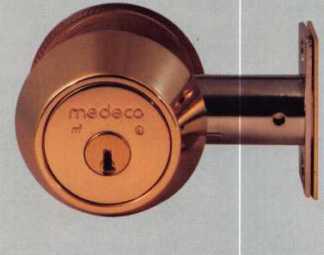

SALEM, Va., (August 24, 2006) - Medeco High Security Locks is introducing a running change to the award-winning Maxum deadbolt lock. Independent consumer testing labs rated Maxum to be the strongest deadbolt available. The Maxum deadbolt is BHMA Grade 1 Certified, unlike many other dead­bolts on the market.

Changes to the design provide easy installation even in less than ideal applications. Engineering enhance­ments allow for a smaller shield to protect against ice pick attacks, addi­tional hardened steel components to protect against drilling, and self­

adjusting components to allow for installation on 1 door to 2 thick doors with no additional parts required. The strong bolt mecha­nism has been enhanced with an accelerator spring to assist in throw­ing and retracting the bolt.

Maxum deadbolts with new and improved features were introduced at ALOA and will begin shipping in September.

Medeco Maxum deadbolts are avail­able through Medeco and authorized Medeco distributors, located by call­ing Medeco Customer Service in the U.S. at 1-800-839-3157 and in Canada at 1-888-633-3264.

New Serialized Key Control product from DORMA Offers Unprecedented Flexibility, Web-based Tracking

REAMSTOWN, Pa. - To dramatically simplify the process of user authorization at the secure site. End users and factory author­

tracking and ordering keys - without compromising security or key control - DORMA Architectural Hardware has developed a new Serialized Key Control (SKC) concept that creates key control through a national network of authorized key makers using a web- based tracking system.

The innovative SKC program uses keys that are laser engraved with unique serial numbers, allowing DORMA-approved hardware dis­tributors and key makers to stock key blanks and cylinders. This approach provides the opportunity to support both factory and locally keyed projects.

The secure, web-based tracking tool provides a historical record of the keys issued to each company. Dealers and locksmiths verify end

ized key makers can track their key duplication history without sending any personal information or key bittings over the Internet.

The SKC program uses a seven-pin cylinder rather than a six-pin- cylinder, providing greater keying capacity for the end user. The DORMA seven-pin cylinder fits in the footprint of a conventional six-pin cylinder.

DORMA SKC cylinders are available in rim, mortise, key-in- knob/lever, and small format interchangeable core configurations. The SKC product allows interkeying of conventional cylinder and interchangeable cores, and can be used in DORMA's complete line of grade one and two locksets as well as retrofitting Schlage and Best products.

Keynotes • October 2006

New Products: DeWalt Launches New XRP™ Drills with Significantly More Speed to Complete Applications -

Drills Designed with Improved High Efficiency Motor and Innovative Chuck Systems

June 2006 — DeWALT, a leading manufacturer of industrial power tools, has built seven new heavy-duty XRP™hammerdrill/drill/driv- ers from the ground up with significant performance, chuck and durability enhancements. The XRP™ line includes three 18V mod­els (DC926KjVVA,DC925KA/VA and DC920KA), three 14.4V models (DC936KA/VA, DC935KA/VA and DC930KA) and a 12V model (DC940KA).

The new XRP™ 18V drills provide end users with a 13 percent increase* in speed of application versus the closest 18 V competitor, an advantage that will be most noticeable to professional contractors when completing applications that require large diameter bits such as self-feed and ship auger bits. In order to obtain this speed of application advantage, DeWALT built each drill with a high power, high efficiency motor that delivers maximum performance in drilling and fastening applications. DeWALT also made improve­ments to the transmission, allowing it to handle the increase in power from the new motor, clutch and switch. In addition, the new XRP™ drills have 10 percent longer run-time** than the previous line of XRP™ drills.

The XRP™ hammerdrills (DC926KA, DC925KA, DC936KA, DC935KA) come with a 1/2" self-tightening chuck that is unique to DeWALT drills. The innovative chuck system tightens through­out the application to prevent bits from slipping. For improved

performance and durability, the chuck is designed with debris vents that allow dust and debris to escape during use, which is particularly useful in overhead applications.

The XRP™ drill/drivers (DC920KA, DC930KA, DC940KA) are equipped with a unique 1/2" single sleeve axial locking chuck, which features a locking sleeve that slides back to lock the jaws of the chuck onto the bit. This feature helps to prevent the sleeve from unlocking during high vibration applications, as well as during drilling applications performed in tight quarters where the sleeve rubs against objects.

Each hammerdrill/drill/driver in the new XRP™ line has a patented 3-speed transmission that optimizes the speed applied to each appli­cation, offering professional end users maximum performance for various applications. For example, first speed is ideal for drilling large holes in wood using large diameter hole saws and self-feed bits. Second speed is ideal for use with auger bits and screwdriving, while third speed is most commonly used for hammer drilling into con­crete.

To provide maximum jobsite durability, DeWALT drills are built with a new switch, transmission, and clutch, as well as an improved motor design. Each of these features help the drills to withstand the most extreme jobsite environment conditions and allow users to complete the most demanding jobsite applications.



Using a general purpose  
lubricant? **Be professional!**Use a specially formulated  
lubricant for the Locksmith  
and Safe Technician trade.  
You and your customers will  
be well pleased. **Guaranteed!**

$48°° + shipping per case.

12 -1 loz. cans per case minimum order.  
Order via phone or fax. Credit cards accepted.  
Net 30 W.A.C. or send check with order.

Coast Safe & Lock Co., Inc.

P.0. Box 66257 • Mobile, AL 36606  
(251) 479-5264 • Fax (251) 471-6967



Keynotes • October 2006

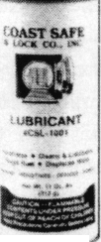

**Classifieds**



EMPLOYMENT

LOCKSMITH WANTED

Experience & hardware knowl­edge preferred. Apprentice posi­tions open for right individual. Excellent benefits include use of vehicle & tools, uniform, vaca­tion and personal time, health insurance, 401 (k). Background check required. Clean MVR required. Fax 303-291-01 13 or send resume & MVR to Colorado Doorways, 3333 E. 52nd Ave., Denver, CO 80216. [www.codoor.com](http://www.codoor.com), email: [hr@codoor.com](mailto:hr@codoor.com). EOE M/F/D/V

LOCKSMITH TECHNICIANS WANTED

In house locksmith with experi­ence road and shop work for commercial, safe and access control service. Salary plus ben­efits. See website or call for details. 713-755-5906. Apply in person at 1310 Prairie, 2nd floor, Houston, Texas 77002. [www.co.harris.tx.us/hrrm/](http://www.co.harris.tx.us/hrrm/) Employment.htm

LOCKSMITH WANTED

Locksmith wanted at Lee's Lock & Safe in Encinitas, California! Commerical, Residential, Electronic Access Control &

Safes a plus. Fast paced and good benefits. Located in beauti­ful North Coastal San Diego County. In business since 1970. Fax: 760-753-5851,

Ph: 760-753-0825.

LOCKSMITH WANTED

South King County Locksmith Company (locations in SeaTac and Federal Way) needs inside locksmiths as well as outside technicians. Top benefits pack­age and top pay. Medical,

401 K, paid vacation and plenty of opportunity for advancement. We will supply everything you need (tools, truck, uniform)> Please email or fax resume to: [paulbrandon@lockguys.com](mailto:paulbrandon@lockguys.com) or give me a call at 253-261-3870.

30819 Pacific Highway South Federal Way, WA 98003

EMPLOYMENT OPPORTUNITY Locksmith - Entry

Level/Experienced - A true career opportunity in Las Vegas for enthu­siastic and dependable people! A&B Security Group is seeking entry level or experienced lock­smiths to join our dynamic and growing security services organi­zation. On the job training and advancement opportunities into many areas such as alarms,

CCTV, access control systems, safes and more. Join the A&B Security Group team and receive competitive salary and excellent benefits which include: Minimum first year salary $30,000, 401K, hospitalization package, paid hol­idays, company vehicles, even a relocation allowance! A&B Security Group is currently accept­ing applications from interested and qualified candidates to fill the open Locksmith positions. Come work for A&B Security Group in Las Vegas and you'll stay in Las Vegas! Apply on our website [www.227lock.com](http://www.227lock.com) or call 702- 227-LOCK and ask for Phil today!

Classified Advertising Policy

Classified advertising space is provided free of charge to ALOA members and for a fee of $2.00 per word, $40.00 minimum for non members. Classified ads may be used to advertise used merchandise and overstocked items for sale, "wanted to buy" items, business opportunities, employment opportunities/positions wanted and the like. Members or non members wishing to advertise services or new merchandise for sale may purchase a "Commercial Classified Ad" for a fee of $4.00 per word with a minimum of $100.00. Each ad will run for two issues. For blind boxes there is a $10.00 charge for members and non members. All ads must be submitted in writing to the Advertising Sales Department via fax at 817-645-7599 or through an email to [adsales@aloa.org](mailto:adsales@aloa.org) by the fifteenth of the month two months prior to issue date. ALOA reserves the right to refuse any classified adver­tisement that it deems inappropriate according to the stated purpose of the classified advertising section.



KEY CODE SERVICE

With proper ID and security clearance

we can get codes for most cars.

Fax us at 1 -800-695-6810  
or call 1-800-741-4764  
for more information.

Hello, I'm Doug Jameson of Jameson Code Services. We would like to try and make your  
business just a little easier when you make a key. We can furnish a key code to you for almost  
all cars. There is no charge should the code we provide not work. We can have most codes  
back to you within 30 minutes. Some codes are even quicker such as Ford and Toyota. We  
furnish a pin number for Chryslers, also brake codes and immobolizer codes  
for Hondas and Acuras. We have been in the key code business since 1995 and learn a little  
more everyday. We are open Monday thru Friday 8:30 a.m. to 6:00 p.m. All codes are  
$15.00. The $15.00 also includes the pin number, brake code and immobolizer code.

We would appreciate your input and welcome suggestions for improving our service. Give us  
a call at 214-630-0477 to set up your account or to have any questions answered. Looking  
forward to servicing all locksmiths. Fords and Chryslers within 15 minutes!

FYI: We are now open on Saturdays 9:00 a.m. to 1:00 p.m.

All codes are $15.00 on Saturday

We are accepting applications from ALOA Members only.

Fax us at 1-800-695-6810  
or call 1-800-741-4764

WANTED TO BUY/SELL

BUSINESS FOR SALE

Mom and Pop Locksmith and Screen Business for Sale in Golden Valley, Arizona. Located between Kingman, AZ and Laughlin, AZ in fast growing Mohave County. Health and age are our reasons for selling. Our Dodge Ram Van and Business have more than $75,000.00 in equipment and inventory. All is included. Three bedroom, two bath 24x24 detached garage (which now houses the business) on 1.7 acre lot with all utilities and no assessments owed. Make an offer that is reasonable for this area. 928-565-2294 or email at [lmburks@citlink.net](mailto:lmburks@citlink.net)

BUSINESS FOR SALE

Sacramento, California Locksmith Business with two fully equipped vans, full inventory, tools, keys and code machines, etc. Established customer base since 1976, leased store in shopping center. Contact Walter Marcotte, owner, Jeff's Locksmiths. Lie# 706234 2377 Arden Way, Sacramento California 95825.

Fax 916-929-5945 Phone 530-674-3411 Randy's Cell Phone 916-600-1557

FOR SALE

Original Curtis key blanks.

Dan Barrow 601-624-8185.

36

LOCKSMITH BUSINESS FOR SALE

Located in Chicago south subur­ban area. Shop is well estab­lished, 35 years in same loca­tion, business has many com­mercial/industrial accounts. Equipment and inventory are included. Owner relocating will help with transition. Please call 708-424-6953.

FOR SALE - ALL ITEMS LIKE NEW!

RETIRED - PRIMUS Demo kit with lock out cylinder - $195. Everest Demo kit - $195. Schlage Finish samples - $15. Solid Oak mount 44-112 - $50. Single mount composite material - $25. Sold individually or $425. Takes all!!!! Contact John L. Kish. Member# 12431 Telephone 1-888-7233.

Email: [kishjohn@softhome.net](mailto:kishjohn@softhome.net)

FOR SALE

Many new and gently used Omnilock OM and OP 2000 locks. For prices and more infor­mation, please email [Omnilocksforsale@aol.com](mailto:Omnilocksforsale@aol.com) or fax 860-346-6667

BUSINESS FOR SALE

Turnkey locksmith company incorporated. All inventory and equipment, new $10,000 com­puterized system, domain name, phone lines & vehicles. Prime location since 1979. High foot & return client business. Loyal employees, customer base

includes national retail chains. Alarm and proprietary key sys­tems assures repeat business. Grow in a vibrant area in Seattle, Washington, where new construction projects abound. Call Verlayn McManus,

RE/MAX Northwest at 1-866-733-5788 or send email to [vmcmanus@remax.net](mailto:vmcmanus@remax.net).

MOBILE BUSINESS FOR SALE IN MIAMI, FLORIDA

15 year old, well established business. 90% commercial. Very good accounts. 2000 Ford Econoline Van .75 ton, HPC 1200, HPC 9160, all pinning kits, blanks, hand tools and stock included. $190,000. Also HPC 1200 blitz, 6 months old, 30 min use, $ 1,000.

Call Brad 305-233-4447

LOCKSMITH BUSINESS FOR SALE

Growing East Tennesse lock­smith business established 1987. Supports three locksmiths with two fully equipped vans serving residential & commercial accounts as well as walk-in cus­tomers. Business located in a 1152 sq.ft, concrete building on a 7500 sq.ft, corner lot fronting main hwy. Complete set up $225,000. Call 423-586-3101 M-F 8-5.

Keynotes • October 2006

A MILLION DISASTERS TO PROTECT AGAINST

OVER 200 STYLES TO CHOOSE FROM. JUST ONE NAME TO REMEMBER.



With a newly expanded line of UL®-rated safes, Adesco provides the best available protection against fire, impact, burglary and other disasters. Whether your customer base is primarily retail & commercial, US government, or residential, Adesco has literally hundreds of models and styles to suit their needs and protect their vital records, cash, and assets. Offer the best. Offer Adesco. 1-800-694-9340 • [www.adesco.com](http://www.adesco.com)

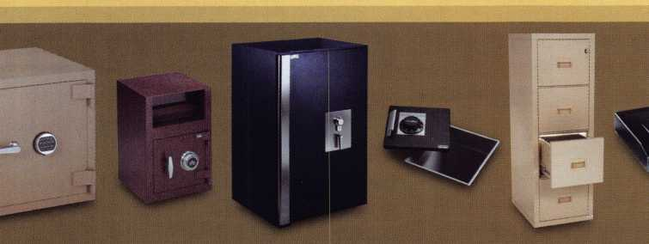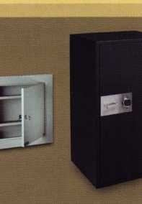

A member of the FireKing® Security Group.



Distributor

**1st In Hardware, Inc.**

Phone: Phone: 410-646-9900 Fax: 410-646-0045 www. 1 stinhardware.com

**ADEL Fingerprint Technology, LLC**

Phone: 909-595-1222 Fax: 909-595-1667

**Accredited Lock Supply Co.**

Phone: 800-652-2835 Fax: 201-865-2435 [www.acclock.com](http://www.acclock.com)

**Andrews Wholesale Lock Supply**

Phone: 717-272-7422 Fax: 717-274-8659 [www.andrewslock.com](http://www.andrewslock.com)

**Boyle & Chase Inc.**

Phone: 800-325-2530 Fax: 800-205-3500 [www.boyleandchase.com](http://www.boyleandchase.com)

**Clark Security Products**

Phone: 858-974-6740 Fax: 858-974-6720 [www.clarksecurity.com](http://www.clarksecurity.com)

**Cook's Building Specialties**

Phone: 505-883-5701 Fax: 505-883-5704

**Dire's Lock & Key Company**

Phone: 303-294-0176 Fax: 303-294-0198

**Direct Security Supply, Inc.**

Phone: 800-252-5757 Fax: 800-452-8600

**Discount Key Machines.Com/Busch**

Phone: 800-332-8724 Fax: 407-363-4666

**Doyle Security Products**

Phone: 800-333-6953 Fax: 612-521-0166 [www.doylesecurity.com](http://www.doylesecurity.com)

**Dugmore and Duncan, Inc.**

Phone: 888-384-6673 Fax: 888-329-3846

**E. L. Reinhardt Co., Inc.**

Phone: 800-328-1311 Fax: 651-481-0166 [www.elreinhardt.com](http://www.elreinhardt.com)

**Ewert Wholesale Hardware**

Phone: 800-451-0200 Fax: 708-597-0881

**Foley-Belsaw Company**

Phone: 800-821-3452 Fax: 816-483-5010 [www.foley-belsaw.com](http://www.foley-belsaw.com)

**Fried Brothers Inc.**

Phone: 800-523-2924 Fax: 215-592-1255 [www.fbisecurity.com](http://www.fbisecurity.com)

**H.L. Flake Co.**

Phone: 800-231-4105 Fax: 713-926-3399 [www.hlflake.com](http://www.hlflake.com)

**Hans Johnsen Company**

Phone: 214-879-1550 Fax: 214-879-1530 [www.hjc.com](http://www.hjc.com)

**Hardware Agencies, Ltd.**

Phone: 416-462-1921 Fax: 416-462-1922 [www.hardwareagencies.com](http://www.hardwareagencies.com)

**IDN Incorporated**

Phone: 817-421-5470 Fax: 817-421-5468 [www.idn-inc.com](http://www.idn-inc.com)

**Instant Hardware Delivery, Inc**

Phone: 800-355-1107 Fax: 800-663-8518

**Intermountain Lock & Supply**

Phone: 800-453-5386 Fax: 801-485-7205 [www.intermountainlock.com](http://www.intermountainlock.com)

**International Electronics, Inc**

Phone: 800-343-9502 Fax: 617-821-4443

**Jo Van Distributors**

Phone: 416-288-6306 Fax: 416-752-8371 [www.jovanlock.com](http://www.jovanlock.com)

**L V Sales Inc**

Phone: 323-661-4746 Fax: 323-661-1314 [www.lvsales.com](http://www.lvsales.com)

**Lockmasters, Inc.**

Phone: 859-885-6041 Fax: 859-885-7093 [www.lockmasters.com](http://www.lockmasters.com)

**Locks Company**

Phone: 800-288-0801 Fax: 305-949-3619

**Locksmith Ledger International**

Phone: 847-454-2700 Fax: 847-454-2759 [www.lledger.com](http://www.lledger.com)

**McDonald Dash Locksmith Supply**

Phone: 800-238-7541 Fax: 901-366-0005 [www.mcdonalddash.com](http://www.mcdonalddash.com)

**Monaco Lock Co.**

Phone: 800-526-6094 Fax: 800-845-5625 [www.monacolock.com](http://www.monacolock.com)

**NLS Lock Supply Dba Nevada Lock S**

Phone: 702-737-0500 Fax: 702-737-7134

**Omaha Wholesale Hardware**

Phone: 800-238-4566 Fax: 402-444-1664 [www.omahawh.com](http://www.omahawh.com)

**Phoenix Safe International LLC**

Phone: 765-483-0954 Fax: 765-483-0962 [www.phoenixsafeusa.com](http://www.phoenixsafeusa.com)

**Positive Identity Solutions**

Phone: 704-663-1175 Fax: 704-660-1301 [www.pids-usa.com](http://www.pids-usa.com)

**Security Distributors Inc**

Phone: 800-333-6953 Fax: 612-524-0166

**Security House**

Phone: 905-669-5300 Fax: 905-660-6313 [www.securityhouselock.com](http://www.securityhouselock.com)

**Southern Lock and Supply Co.**

Phone: 727-541-5536 Fax: 727-544-8278 [www.southernlock.com](http://www.southernlock.com)

**Stone & Berg Wholesale**

Phone: 800-225-7405 Fax: 800-535-5625

**Streetwise Security Products**

Phone: 252-830-5577 Fax: 252-830-5542

**The Locksmith Store Inc.**

Phone: 847-364-5111 Fax: 847-364-5125 [www.locksmithstore.com](http://www.locksmithstore.com)

**Timemaster Inc.**

Phone: 859-259-1878 Fax: 859-255-0298 [www.time-master.com](http://www.time-master.com)

**Top Notch Distributors, Inc.**

Phone: 800-233-4210 Fax: 800-854-4146 [www.topnotch.bz](http://www.topnotch.bz)

**Turn 10 Wholesale**

Phone: 800-848-9790 Fax: 800-391-4553

**U.S. Lock Corp.**

Phone: 800-925-5000 Fax: 800-338-5625 [www.uslock.com](http://www.uslock.com)

**Wilson Safe Company**

Phone: 215-492-7100 Fax: 215-492-7104 [www.wilsonsafe.com](http://www.wilsonsafe.com)

Manufacturer

**A & B Safe Corporation**

Phone: 800-253-1267 Fax: 856-863-1208 www. a-bsafecorp. com

**ABUS Lock Company**

Phone: 800-352-2287 Fax: 602-516-9934 [www.abus.com](http://www.abus.com)

**Access Security Products Ltd.**

Phone: 905-337-7874 Fax: 905-337-7873 [www.access-safe.com](http://www.access-safe.com)

**Adams Rite Mfg Company**

Phone: 800-872-3267 Fax: 800-232-7329 [www.adamsrite.com](http://www.adamsrite.com)

**Adesco Safe Mfg. Company**

Phone: 800-694-9340 Fax: 562-408-6427 [www.adesco.com](http://www.adesco.com)

**Adrian Steel Company**

Phone: 800-677-2726 Fax: 517-265-5834 [www.adriansteel.com](http://www.adriansteel.com)

**Advanced Diagnostics USA Inc**

Phone: 650-876-2020 Fax: 650-876-2022 [www.autokeys.com](http://www.autokeys.com)

**Alarm Controls Corporation**

Phone: 631-586-4220 Fax: 631-586-6500 [www.alarmcontrols.com](http://www.alarmcontrols.com)

**All Five Tool Company, Inc.**

Phone: 860-583-1691 Fax: 860-583-4516 [www.all5tool.com](http://www.all5tool.com)

**American Security Products**

Phone: 909-685-9680x2013 Fax: 909-685-9685 [www.amsecusa.com](http://www.amsecusa.com)

**BWD Lockcraft**

Phone: 973-728-3707 Fax: 973-728-3731 [www.bwdautomotive.com](http://www.bwdautomotive.com)

**Bianchi USA, Inc.**

Phone: 800-891-2118 Fax: 216-803-0202 [www.bianchi](http://www.bianchi) 1770usa.com

**Buddy Products**

Phone: 312-733-6400 Fax: 312-733-8356 [www.buddyproducts.com](http://www.buddyproducts.com)

**CCL Security Products**

Phone: 800-733-8588 Fax: 847-537-1800 [www.cclsecurity.com](http://www.cclsecurity.com)



Keynotes • October 2006

|  |  |  |  |  |  |  |  |
| --- | --- | --- | --- | --- | --- | --- | --- |
|  | a s | s o | C | •  1 | a t | CD |  |
|  |  | mem | b | e | r s |  |  |
| CompX Security Products | Ingersoll Rand Security | | MUL-T-LOCK USA, Inc. | | |  | Security Door Controls |
| Phone: 864-297-6655 | Technologies |  | Phone: 800-562-3511 | | |  | Phone: 805-494-0622 |

Fax: 864-297-9987 [www.compxnet.com](http://www.compxnet.com)

**D&D Technologies (USA), Inc.**

Phone: 714-677-1300x292 Fax: 714-677-1299 [www.ddtechglobal.com](http://www.ddtechglobal.com)

Phone: 317-805-5713  
Fax: 317-805-5779  
[www.schlagelock.com](http://www.schlagelock.com)

**Jackson Corporation**

Phone: 323-269-8111  
Fax: 800-888-6855

Fax: 973-778-4007 [www.mul-t-lockusa.com](http://www.mul-t-lockusa.com)

**Major Mfg, Inc.**

Phone: 714-772-5202 Fax: 714-772-2302 [www.majormfg.com](http://www.majormfg.com)

Fax: 805-494-8861 [www.sdcsecurity.com](http://www.sdcsecurity.com)

**Security Solutions**

Phone: 405-376-1600 Fax: 405-376-6870 [www.securitysolutions-usa.com](http://www.securitysolutions-usa.com)

**DETEX Corp.**

Phone: 800-729-3839 Fax: 830-620-671 1 [www.detex.com](http://www.detex.com)

**Don-Jo Manufacturing, Inc.**

Phone: 978-422-3377 Fax: 978-422-3467 [www.don-jo.com](http://www.don-jo.com)

**Door Controls International**

Phone: 800-742-3634 Fax: 800-742-0410 [www.doorcontrols.com](http://www.doorcontrols.com)

**Door Jamb Armor/A&G Security**

Phone: 201-490-5381 Fax: 201-490-5389 [www.djarmor.com](http://www.djarmor.com)

**Doorking Inc.**

Phone: 800-826-7493 Fax: 310-641-1586 [www.doorking.com](http://www.doorking.com)

**Dorma Architectual Hardware**

Phone: 717-336-3881 Fax: 717-336-2106 [www.dorma-usa.com](http://www.dorma-usa.com)

**E-Lock USA**

Phone: 434-589-5913 Fax: 434-589-3738 [www.e-lock-usa.com](http://www.e-lock-usa.com)

**FireKing Security Products**

Phone: 800-457-2424 Fax: 800-896-6606 [www.fkisecuritygroup.com](http://www.fkisecuritygroup.com)

**Framon Manufacturing Company Inc.**

Phone: 989-354-5623 Fax: 989-354-4238 [www.framon.com](http://www.framon.com)

**G-U Hardware Inc.**

Phone: 757-877-9020 Fax: 757-877-9720 [www.g-u.com](http://www.g-u.com)

**HPC, Inc.**

Phone: 847-671-6280 Fax: 847-671-6343 [www.hpcworld.com](http://www.hpcworld.com)

**HY-KO Products Co.**

Phone: 330-467-7446 Fax: 330-467-7442

**Hammerhead Industries, Inc.**

Phone: 805-658-9922 Fax: 805-658-8833 [www.gearkeeper.com](http://www.gearkeeper.com)

[www.jacksonexit.com](http://www.jacksonexit.com)

**Jet Hardware Mfg., Co.**

Phone: 718-257-9600 Fax: 718-257-0973 [www.jetkeys.com](http://www.jetkeys.com)

**KABA ILCO Corp.**

Phone: 252-446-3321 Fax: 252-446-4702 [www.kaba-ilco.com](http://www.kaba-ilco.com)

**KEY-BAK/West Coast Chain Mfg.**

Phone: 909-923-7800 Fax: 909-923-0024 [www.keybak.com](http://www.keybak.com)

**Kenstan Lock Company**

Phone: 516-576-9090x315 Fax: 516-576-0100 [www.kenstan.com](http://www.kenstan.com)

**Keri Systems Inc.**

Phone: 408-451-2520 Fax: 408-441-0309 [www.kerisys.com](http://www.kerisys.com)

**Knaack Manufacturing Co.**

Phone: 800-456-7865 Fax: 815-459-9097 [www.weatherguard.com](http://www.weatherguard.com)

**Kustom Key Inc.**

Phone: 800-537-5397 Fax: 800-235-4728 [www.kustomkey.com](http://www.kustomkey.com)

**LAB Security**

Phone: 800-243-8242 Fax: 860-583-7838 [www.labpins.com](http://www.labpins.com)

**La Gard Inc.**

Phone: 310-325-5670 Fax: 310-325-5615 [www.lagard.com](http://www.lagard.com)

**Lock America, Inc. dba L.A.I. Group**

Phone: 714-373-2993 Fax: 714-373-2998 [www.laigroup.com](http://www.laigroup.com)

**LockPicks.Com/Brockhage Tools**

Phone: 408-437-0505 Fax: 408-516-9642

**Lucky Line Products, Inc.**

Phone: 858-549-6699 Fax: 858-549-0949 [www.luckyline.com](http://www.luckyline.com)

**M.A.G. Manufacturing**

Phone: 714-891-5100 Fax: 714-892-6845 [www.magmanufacturing.com](http://www.magmanufacturing.com)

**Maxcess Card Systems Ltd**

Phone: 949-492-5964 Fax: 949-492-0415 [www.maxcess-card.com](http://www.maxcess-card.com)

**Medeco Security Locks**

Phone: 540-380-5000 Fax: 540-380-5010 [www.medeco.com](http://www.medeco.com)

**Mil-Comm Products Co Inc**

Phone: 201-935-8561 Fax: 201-935-6059

**Promet Safe Inc.**

Phone: 860-436-6246 Fax: 860-436-6876 www. p ro m et-sa f e. co m

**Protex Safe Co., LLC**

Phone: 818-610-8030 Fax: 818-610-8004 [www.protexsafe.com](http://www.protexsafe.com)

**ROFU International Corp.**

Phone: 253-922-1828 Fax: 253-922-7272 [www.rofu.com](http://www.rofu.com)

**Rutherford Controls Int'l Co.**

Phone: 519-621-7651 Fax: 519-621-7939 [www.rutherfordcontrols.com](http://www.rutherfordcontrols.com)

**STRATTEC Security Corp.**

Phone: 414-247-3333

Fax: 414-247-3564

www. a fte r m a r ket. stra ttec. co m

**Sargent & Greenleaf, Inc.**

Phone: 859-885-9411 Fax: 859-885-3063

[www.sargentandgreenleaf.com](http://www.sargentandgreenleaf.com)

**Sargent Manufacturing Co.**

Phone: 800-727-5477 Fax: 888-863-5054 [www.sargentlock.com](http://www.sargentlock.com)

**Schwab Corp.**

Phone: 765-447-9470 Fax: 765-447-8278 [www.schwabcorp.com](http://www.schwabcorp.com)

**Securifort Inc**

Phone: 819-359-2226 Fax: 819-359-2218 [www.securifort.com](http://www.securifort.com)

**Securitron Magnalock Corp.**

Phone: 775-355-5625 Fax: 775-355-5636 [www.securitron.com](http://www.securitron.com)

**Select Engineered Systems**

Phone: 305-823-5410 Fax: 305-823-5215 [www.selectses.com](http://www.selectses.com)

**Townsteel, Inc.**

Phone: 626-858-5080 Fax: 626-858-3393 [www.townsteel.com](http://www.townsteel.com)

**Videx Inc.**

Phone: 541-758-0521 Fax: 541-752-5285

[www.videx.com](http://www.videx.com)

**WMV Innovation Company**

Phone: 888-474-2341 [www.sure-strike.com](http://www.sure-strike.com)

Service

Organization

**Allstate Insurance Company**

Phone: 847-551-2181 Fax: 847-551-2732 [www.allstate.com](http://www.allstate.com)

**Cardservice Mobile Solutions**

Phone: 561-210-8488 Fax: 561-953-6268 [www.cardservicems.com](http://www.cardservicems.com)

**Cross Country Automotive Services**

Phone: 800-541-2262 Fax: 781-393-0256

[www.argosi.com](http://www.argosi.com)

**Massglass & Door Service**

Phone: 888-742-8837 Fax: 805-497-2255 [www.massglass.com](http://www.massglass.com)

**SalesGenie.Com**

Phone: 402-593-4500 [www.salesgenie.com](http://www.salesgenie.com)

**The Mechanic Group, Inc.**

Phone: 845-735-0700 Fax: 845-735-8383 [www.mechanicgroup.com](http://www.mechanicgroup.com)

**Webster Safe & Lock Co., Inc.**

Phone: 901-332-291 1 Fax: 901-332-2878 [www.webstersinc.com](http://www.webstersinc.com)

Keynotes • October 2006

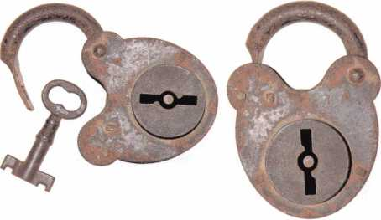

**ALOA VS. "PHONY LOCKSMITHS"**

Much has been discussed lately about the wave of "Phony Locksmiths" cropping up all over the US. Television stations from Milwaukee to Phoenix have been setting up "sting" operations where a station employee calls one of these "local" locksmiths and quotes one price over the phone. When the person shows up, the customer is charged up to four-times as much!

What is ALOA doing to combat this growing concern? We took the initial step last year by revoking the ALOA mem­bership of one of the perpetrators. We have also gathered all links for newspaper and television news stories and put on ALOA website ([www.aloa.org/legislation](http://www.aloa.org/legislation)), including a press release that you can send to your local news outlets. We've sent a letter to all State Attorney Generals, the National Association of Attorneys General, requesting this issue be placed on the agenda at their Consumer Protection Conferences and sent a letter to the Federal Trade Commission. ALOA is following up with other local news stations to highlight this violation of public trust that makes the industry look bad.

ALOA is also asking for your help. Follow up with your State's Attorney General and ask them to address this prob­lem. Send the press release to your local news outlets.

Find out the companies in your area that are defrauding the public and report them to ALOA. If they are members, their actions are a violation of the ALOA Code of Ethics, and they could be removed from the association. Working together, we can restore the public's trust of the security industry.

THIS IS AN IMPORTANT ELECTION YEAR - ESPECIALLY FOR LOCAL ELECTIONS

I would be remised in my duties as Legislative Manager if I didn't remind you that there is a very important General Election on Tuesday, November 7, 2006. Pay special attention to your local elections, because for locksmiths, it's the state elections that really count.

You probably know who your Congressman and Senators are, but do you know who your state Representative and state Senator are? How do they stand on licensing? Are they the chairperson of a committee that will consider any alarm licensing legislation that is introduced? Could they help you introduce locksmith licensing?

One of the best ways to know who your state representative is, would be to check the web. Go to:

<http://capwiz.com/asae/dbq/officials> and enter your zip code.

Click on State and then Go. On the next screen, you may be asked to enter your street address. The site will then give you your state senator and representative. Better yet, it will give you a link to their websites. From their websites, you can see what kind of legislation they introduced or co­sponsored. The idea is to help support those candidates who are good on our issues. Your local ALOA Chapter, Affiliate or regional locksmith association will have insight on politicians who they may have a great working relation­ship. While ALOA would never tell you who to vote for, it's good to be an informed voter!

Keynotes • October 2006

HISTORIC CALIFORNIA LEGISLATION SIGNED INTO LAW

On Saturday, September 23, Governor Arnold Schwarzenegger signed into law California Senate Bill 1542, which requires a motor vehicle manufacturers of new motor vehicles sold or leased on and after January 1, 2008, to provide the means whereby registered owners may, through a registered locksmith, access the infor­mation that is necessary to permit the produc­tion of a replacement key or other functionally similar device by the registered locksmith that will allow the owner to enter, start, and operate the vehicle.

The Associated Locksmiths of America, Inc. (ALOA) worked closely with the California Locksmith Association (CLA), the Automobile Club of Southern California and the California State Automobile Association (AAA) to educate legislators on the need for such a law.

Consumers in California who lost the keys to their car would have to wait for hours for the dealerships to replace their keys. Frequently, consumers would have to tow their car to the dealership, or have to go without their car if the incident happened over a weekend when the dealerships were closed. This hill is a big step for California consumers by allowing registered locksmiths key code information 24/7.

Special thanks to John Brueggeman, President of CLA, who spent countless hours traveling to Sacramento working with ALOA and AAA to make sure locksmiths were involved at every level.

Key provisions of the hill include:

1. Makes various findings and declarations regarding the need for vehicle owners to be able to gain entry to and operate their vehicles in a timely, convenient, and reliable manner.
2. Requires motor vehicle manufacturers of new motor vehicles sold or leased on and after January 1, 2008, to provide the means whereby registered owners may, through a registered locksmith, access the information that is neces­sary to permit the production of a replacement key or other functionally similar device by the registered locksmith that will allow the owner to enter, start, and operate the vehicle.
3. Requires the means to access this information to be available by telephone or electronically 24 hours a day and seven days a week.
4. Specifies security procedures that must be fol­lowed by the vehicle's registered owner, the reg­istered locksmith, and the vehicle manufacturer in order for the needed key duplication informa­tion to be made available by the manufacturer to the locksmith, and immunizes the manufac­turer and locksmith from liability for theft of the vehicle if the statutory procedures are followed. These procedures include having the locksmith verify the identity of the requesting vehicle owner, and that the registration address matches the owner's address, and having the locksmith destroy all information in his or her possession that was accessed from the vehicle manufacturer after giving it to the vehicle owner.

Manufacturer responsibilities would include requiring the locksmith to confirm his or her registration, complying with other reasonable authentication procedures, and confirming the verifications described above.

1. Defines, for the purposes of this hill, a "regis­tered locksmith" as a locksmith licensed and bonded in California that has registered with a motor vehicle manufacturer and has been issued a registry number and security password by the manufacturer. A registered owner would also include a lessee of the vehicle when the lessee's name appears on the vehicle registration.
2. Defines, for the purposes of this bill, "infor­mation" to include the vehicle's key code, immo­bilizer or access code, and any successor technol­ogy or terminology.
3. Defines, for the purposes of this bill, "motor vehicle" to mean a passenger vehicle, but not a housecar, motorcycle, or other two-wheeled motor vehicle.
4. Exempts from this bill's requirements, until January 1, 2013, a vehicle manufacturer's vehi­cle line that sold between 2,500 and 5,000 vehi­cles in the prior calendar year in California.
5. Specifies that this bill does not apply to a vehicle line of a motor vehicle manufacturer that on January 1, 2006, does not provide for the reproduction of a key or other functionally similar device that allows the vehicle to he entered, started, and operated, by anyone other than the vehicle manufacturer itself and only

itself, provided that the vehicle manufacturer operates a telephone or electronic request line 24 hours a day and seven days a week and, upon the request of the registered owner or his or her family member, furnishes to the regis­tered owner at a reasonable cost within one day of the request or via the next overnight delivery, a replacement key or other functionally similar device that will allow the vehicle to be entered, started, and operated.

1. Sunsets the provisions described in #9 above on January 1, 2013.
2. Specifies that this hill does not apply to a manufacturer that sold fewer than 2,500 vehi­cles in California in the prior calendar year.
3. Allows vehicle manufacturers to perform the duties assigned to them by this bill either by themselves or through the use of a contract agent.
4. Provides that if, subsequent to January 1, 2008, a vehicle line of an exempted manufac­turer provides for the reproduction by anyone, other than the vehicle manufacturer itself, of a key or other functionally similar device that will allow the vehicle to be entered, started, and operated, this bill's provisions will apply to that vehicle line.
5. Provide that this bill's provisions are sever­able, so that if any particular provision is held inactive, that invalidity will not affect this bill's other provisions.

**Renew your commitment by joining the Legislative Action Network Council!**

The Legislative Action Network Council is an important instrument in raising the standards of our profession through the legislative process by making sure that locksmiths have the final say in how our industry will be run. If you con­tribute $100 or more to the Legislative Action Fund you become a member of the prestigious Legislative Action Network (LAN) Council.

As a Council member, you will receive:

• The quarterly Legislative Action Network Update alerting you to important legislation in your state and around the country (same as LAN members)

X • A comprehensive guide to lobbying in your state capital, so you can be the "voice of ALOA" to legislators.

X • A lapel pin designating you as a special ALOA LAN Council member.

X • Recognition in Keynotes magazine.

X • Invitation to exclusive functions at the annual ALOA convention for LAN Council members.

X • Complimentary Legislative Convention merchandise.

It's simple to join the LAN Council:

X Log into the ALOA Store at <http://www.aloa.org/store> X Click on Search and type in "Council"

X From there you can join at four different donor levels X Add this to your basket and checkout!

Note: if this is the first time you have used the ALOA Store, you will need to *et up a username and password.



Keynotes • October 2006

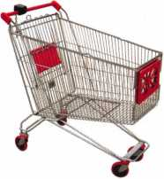

keynotes

**Buye r**

's **Marketplace**

fry SAFE CORPORATION

yw LARGEST

DEPOSITORIES IN THE INDUSTRY

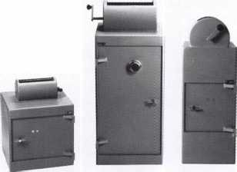

WS-10 WS-40 AB-S

800-253-1267

114 S. Delsea Drive, Suite 3 856-863-1186

Glassboro, NJ 08066 Fax 856-863-1208

IN-STOCK...MORE SAFES

***FREE Freight Program***

***(30 States)***

AMSEC FireKing **fiaiftall HAYMAN** MEIUNK y/CTOK

**TURD I©**

**WHOLESALE SERVICE**

800-848-9790

**ekey Fingerprint  
Access Control**

**TOCAhome**

**Standalone**

**TOCAnet**

**Network**

**Weather Resistant  
Self-Cleaning Scanner  
User Friendly**

**Your Finger is the Key**

**Systems**

Keynotes • October 2006

**(941)782-1227**

**[www.ekeyUSA.com](http://www.ekeyUSA.com)**

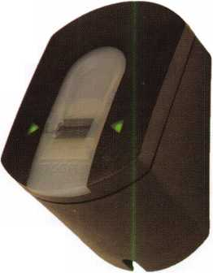

Facts on Sargent punches.

These new hand operated punches have a few unique features, plus specifications that are worthy enough to mention.

Two models are available, BP201-SGT-L and BP201- SGT-R.

Depending on milling (profile), the blanks are inserted one side or the other. Example; The L series is inserted from the left side and cuts bow to tip. The R series is inserted from the right side and cuts tip to bow, similar to IC products.

If your need is greater for R series, then the BP201- SGT-R will generate them from bow to tip, and the L series tip to bow. Models L or R, each does both.

The choice is yours.

SPACES:

.215" to first cut center .156" between cut centers up to seven spaces. Factory space tolerance is ± .001".

DEPTHS:

Are in increments of .020", from .330" to .150" for a total of 10 depths 1 - 0 (10). Factory tol­erance is ± .002".

ANGLE:

Sharpest of most commercial specifications is 78 to 79 degrees. Tolerance if any is not specified by Sargent.

FLAT:

Small .051". No tolerance specified.

All of the above are incorporated in each hand punch by;

Locksmithing, Uni. LLC  
Phone: 302-575-0993  
E-mail: [ted@sargentpunch.com](mailto:ted@sargentpunch.com)

Punch SARGENT blanks

to factory specifications.

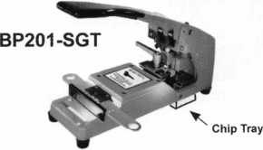

Try them at Yankee • Oct 21-22 and GPLA • Saturday Oct. 28th

Available Exclusively from:

**Locksmithing, Uni. LLC**302-575-0993  
**[www.sargentpunch.com](http://www.sargentpunch.com)**



Keynotes • October 2006



PRESS RELEASE

Date: August 28, 2006

Contact: David M. Lowell, CML, CMST  
Email: [david@aloa.org](mailto:david@aloa.org)

Phone#: 214/819-9733x101

Associated Locksmiths of America speaks out on “Bump Keys”

The Associated Locksmiths of America (ALOA) says that consumers have been unduly alarmed by atten-  
tion-seeking individuals who have used the media to create a panic over recent reports of the use of  
“Bump Keys” to commit burglaries. However, because of the widespread distribution of this information  
through various media, it now has the potential to become a real security threat to consumers.

The technique of using “Bump Keys” is one of many methods used by locksmiths over the past  
75 years to open locks for which there is either a cylinder malfunction or a lost key. There are, in fact,  
many ways to prevent this method of opening so it is not a first-line technique that is used by profes-  
sional locksmiths.

Initially the individuals who promoted this information to the press may have been making what ALOA  
perceives as a misguided attempt at “consumer awareness”. They gave the impression that opening locks  
by “Key Bumping” was a wide-spread problem. It certainly has not been a method used by most burglars  
for many reasons. However, now that this method of opening some locks has become a popular theme,  
the most probable effect will be to stimulate the interest of would-be burglars to attempt to

“Bump Open” locks!

For consumers who are concerned whether their locks or premises are susceptible to this or any other  
form of burglary attack, ALOA recommends that they consult an ALOA Certified Locksmith and ask for  
recommendations for improving security. For information regarding the closest ALOA Certified

Locksmith go to [www.aloa.org](http://www.aloa.org) or call ALOA at

800-532-2562.

The Associated Locksmiths of America (ALOA) is the world s largest organization for locksmiths and  
other physical security professionals. ALOA is dedicated to being the consumer’s first line of defense in  
physical security by increasing the effectiveness and productivity of locksmiths through educational pro-  
grams and materials that address broad security interests. ALOA’s activities include the ALOA  
Continuing Education (ACE) program, the ALOA Annual Convention & Security Expo and the ALOA  
Training Center, which is based in Dallas, Texas. ALOA leads the way for advanced and improved securi-  
ty performance by providing members and the security community with access to a full range of educa-  
tional programs and services.

Keynotes • October 2006

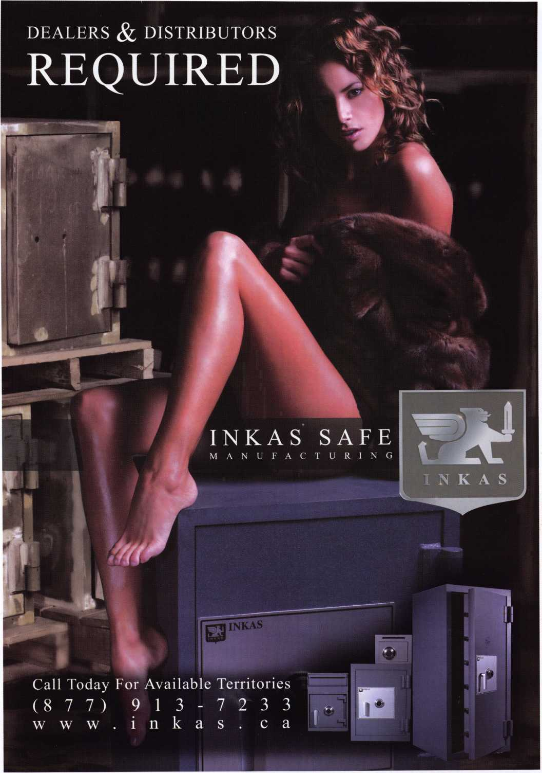

Security Products

**A Division of The Eastern Company**

**301 West Hintz Road Wheeling, IL 60090 Telephone: 800.733.8588 Fax: 847.537.1881 [www.cclsecurity.com](http://www.cclsecurity.com)**

Features & Benefits

* Industrial Strength Combination Lock!
* Resists Hammer and Re-bar Attacks!
* Hardened Steel Full Metal Jacket!
* Hardened Steel Full Metal Jacket Shroud!
* Weather Resistant Black Electrocoating!
* 7/16” Chrome Plated Molybdenum Shackle!
* Inside Shackle Clearances: 1 ” and 2 ”!
* Shackle Pull Strength: 2,750 pounds!
* All Brass Inner Mechanism!
* Four All Brass Dials!
* 10,000 Changeable Combinations!
* Quick Delivery: Shipped from Stock!

